UNIT 1: FOUNDATIONS OF CANADIAN LAW
- Chapter 1: Law and Society (pp.8-33)

The Law reflects societal values and accepted practices. It is fluid and dynamic reflecting the changing and diverse needs of society.

I. Rules v. Laws (pp.10-12)

Rules are accepted norms for behaviour. If broken, they may result in penalties, but they may not. Example: Being late for school may result in detention, but may not.
Law refers to a civilized attempt to fairly and reasonably regulate life in society. A person who breaks the law will face fine, prison, or compensation.
Example: Failing to wear a seatbelt is illegal.
***Remember: rules are not laws, but all laws are rules.

The Rule of Law (pp.13-16)

Question: Why does society need laws?
Answer: Society requires predictability and desires peace and safety.

The Rule of Law is the underlying principle of justice stating that:
1. The law is necessary to regulate society;
2. The law applies equally to everyone; and
3. People are not governed by arbitrary power.

That said, the concept of justice must reflect our collective community standards.

- For examples in R. v. Dudley and Stevens (1884), 14 Q.B.D. 273, Dudley and Stevens were crewmen who killed and consumed a weakened sailor in order to survive. Although charged with murder, the men's sentence was changed from a death sentence to 6 months' imprisonment due to public sympathy.

- However, when a judge granted an absolute discharge to famous fiddler Ashley MacIsaac (who had admitted to possession of marijuana) on the basis that MacIsaac provide an autograph to the judge's wife, the Rule of Law clearly failed.

II. Historical Roots of Law (pp.17-23)

Great Laws of Manu (1280-880 BCE) - Indian laws of trading that became codified (written down)

Code of Li k'vei: (350 BCE) - Chinese codified laws

Code of Hammurabi (1792-1750 BCE) - one of the earliest known sets of codified laws written by King Hammurabi of Babylon. The laws reflected a patriarchal (male dominated) society in which the wealthy were provided with more protection in law than the poor. Slavery, and ownership of women and children, were allowable. Babylonian Law was based on retribution: an eye for an eye distinction. Example: if a physician operates and kills the patient, then the physician's hands shall be cut off.

Conversely, Babylonian law also incorporated the principle of restitution, where payment was made by the offender to the victim of a crime.

Mosaic Law - biblical or Hebrew Law found in the Book of Exodus and often referred to as the Ten Commandments. Under Mosaic Law it was considered illegal to commit murder, adultery or theft.

Greek Law - The first form of democracy was born in Greece where citizens were encouraged to participate in major decisions affecting the running of their country. Voting and jury duty was major responsibilities.

Roman Law - Two major principles of Roman Law:

- The law must be recorded/codified (The Twelve Tablets, among the earliest Roman codes were written on wood and bronze in 450 BCE);
- Justice could not be left in the hands of judges alone to interpret. Lawyers came about during this period.

Justinian's Code – After 395 CE, the Roman Empire was split into the Byzantine Empire and the Western Roman Empire. Byzantine Emperor Justinian (527-565 CE) had specialist clarify the 1600 Books of Roman law and reduce them to Justinian Code. The idea of justice is derived from this code and dealt with areas of civil and criminal law.

Napoleonic Code – After the French Revolution, Napoleon Bonaparte created a new code of laws referred to as the Napoleonic or French Civil Code (1804). The French Civil Code forms the basis of the current Quebec Civil Code.

III. Influences of Canadian Law (pp.24-30)

Early British Law

When the Romans conquered Great Britain in 43 CE, they imposed their laws. This rule lasted until 410 CE when the Romans left the area and local customs took over.

- Trial by Ordeal: when a judge could not reach a verdict based on facts or witnesses, he employed a method known as trial by ordeal. This requires a n accused person to undergo torture to determine guilt or innocence. Trial by ordeal was only used when the sentence was the death penalty. God was said to be the ultimate judge.

Several different ordeals included:
- trial by hot iron (accused forced to hold a piece of hot iron. The burn was bound for a number of a days. When the bandage was removed and the wound healed, then the person was decaled innocent. However, rarely did a wound heal as bandages were not sterile and wounds were susceptible to infection.
- trial by hot water
- trial by cold water (referred to as “swimming a witch” used in witchcraft cases).

B. Trial by Oath Helping: used for less serious charges, trial by oath helping required friends of the accused to swear on the Bible that he or she was innocent. Most people would not help their friends because at this time, they feared punishment from God if they lied.

- Trial by Combat: after the Norman Invasion in 1066, trial by combat was used to determine guilt or innocence by having the parties fight a duel. (Adversarial System: refers to the current day judicial process whereby evidence is presented by two opposing parties usually by way of their lawyers to an impartial judge or jury.)

The Feudal System (p.26)

In 1066, William the Conqueror, Duke of Normandy invaded England. The Battle of Hastings was the battle that changed British history. William established himself as the King of England, head of all Law. This absolute power came from the concept of Divine Right meaning that monarchs and their successors derived their power to rule from God and were accountable only to God. Basically, they were “above the law”.

William instituted a system of land ownership referred to as the feudal system which divided Britain into parcels of land. Each parcel, and everything on it – produce, people, cattle – belonged to a nobleman. Each nobleman was the law on his property. Some were fair, while others were brutal and unreasonable. William’s, grandson, Henry II reformed the legal system giving rise to the Common Law system while also removing the Divine Right of Kings thus reducing the power of the monarchy.

Legal Reforms (pp.27-9)

- Common Law Processes: To bring consistency and fairness, King Henry II (1154-1189) authorized judges to travel to villages and towns and hold court to resolve disputes. These courts were known as assizes and the judges were called circuit judges.

Without written decisions of cases, these judges began to rely on common sense and principles of justice that reflected the community’s sense of what was just and fair. They began to notice similar cases should be decided in similar ways so they began to record their decisions, Case Law. Common Law arose as law that developed in English courts relying on case law that was common to all.

- The Rule of Precedent also arose, meaning that judges would apply a previous decision to a case that has current circumstances. This derived from the Latin phrase stare decisis, meaning to stand by the decision.

- The Jury System was another legal reform. At first, 12 elderly men from the community who knew the lands or boundaries in dispute, were chosen to settle land conflicts.

- The Court System also arose during Henry II’s time so that not only land disputes, but also tax collections, inheritances and criminal offences were heard by the courts.

- After Henry II died, his son, King John, signed the 1215 Magna Carta. Also known as the Great Charter, the Magna Carta, established individual basic rights for the people of England. It recognized the principle known as the Rule of Law which gives everyone equality before the law. No one, not even the King, was above the law.

- Habeas Corpus is another legal reform that came about with the Magna Carta. Habeas Corpus is Latin for “you must have the body”. Basically, it means that within a reasonable amount of time, anyone arrested and detained must be charged via writ (a written document establishing the charge).

- By 1720, six Aboriginal nations formed the Iroquois Confederacy. Their combination of laws concerning adoption, emigration, treason and secession was recorded in a constitution named The Great Binding Law. With greater frequency, Canadian courts are recognizing the importance and validity of Aboriginal laws.

- Chapter 2: Classifying Law (pp.34-50)

I. Three (3) Sources of Law in Canada (pp.35-7)

1. Common Law - originates from decisions made by judges in previous cases.

2. Statute Law -a law passed by government.
Each level of government - federal, provincial, and municipal - has the power to enact law or in its own area of jurisdiction (area of control and authority).
Federal Government - the federal government enacts laws within its own jurisdiction, including criminal law, federal penitentiaries, employment insurance, banking and currency, marriage and divorce, and postal services. Everyone in Canada is subject to these laws .
Provincial Governments - have authority to make laws within their provincial jurisdictions such as laws affecting hospitals, police forces, property rights, highways and roads, and provincial jails.
Local Governments - also referred to as Municipal governments make laws called bylaws that deal with local issues in towns.

3. Constitutional Law - is a body of law dealing with the distribution and exercise of government powers between the federal government and provincial governments. It must be noted that the highest law in the law is the Constitution and it overrides all other laws.

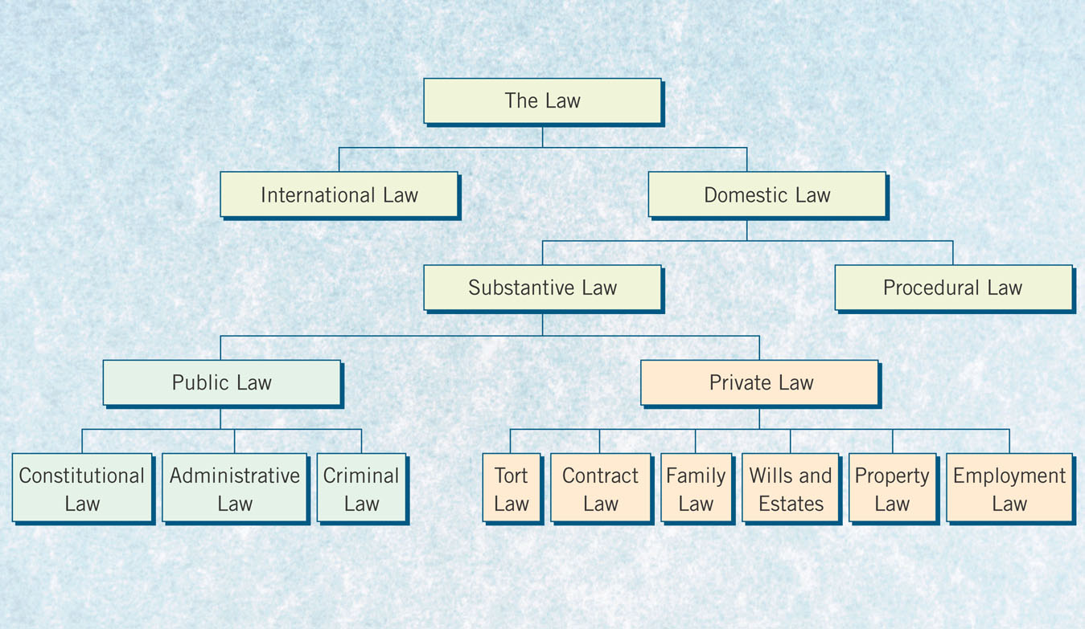
Law in Action. Blair, Costiniuk, eds. (2001) Pearson: Toronto. Figure 2.8. p.45

II. Categories of Law (pp.38-46)

- International Law - is the body of law that governs relations between countries.
Example: Slobodan Milosovic, former President of Yugoslavia was charged with crimes against humanity for mass ethnic cleansing occurring in Serbia in 1999. HIs trial was held at the United Nations highest court for international incidents, the ICJ: the International Court of Justice.)

- Domestic Law - is the body of law that governs activity within a country. A Canadian living in Canada is subject to the laws of Canada, as is any visitor to Canada. But when a Canadian travels outside of Canada, we generally do not have the protection of Canadian law. We are generally subject to the laws of the country we are visiting.

Example: United States v. Burns , [2001] 1 S.C.R. 283. Burns helped brutally murder a family in the United States. He and his accomplice, both Canadians, fled to Canada where they were arrested. Both confessed to the murder. The Supreme Court of Canada ruled that both men could be extradited (or sent back) to the United States to be punished, but that neither would face the death penalty since Canada doesn't have the death penalty. This case shows how Canada and the United States have different domestic laws. Some critics have suggested that this case shows that Canada could become a safe haven from criminal fugitives.

- Procedural Law - law that prescribes methods of enforcing the rights and obligations of substantive law. It includes law referring to gathering evidence, lawful arrest, and trial procedures.
Example: R. v. Burke (2001), 153 C.C.C. (3d) 97 (Ont.C.A.) -the trial judge misheard the verdict and discharged the Accused as the judge thought that the accused had been found Not Guilty of attempted murder. The next day, the judge realized his decision, entered a conviction, sentenced Burke to 12 1/2 years imprisonment. Burke's lawyer appealed and said that the Judge had made a procedural error. The Court of Appeal disagreed and upheld the conviction. But the province was forced to reconsider the procedures for recording jury verdicts to avoid future errors of this type.

- Substantive Law - defines the rights and responsibilities of citizens and levels of government. Substantive laws are divided into public and private Law.

  - Public Law – law related to relationships between individuals and the government. Public Law includes:

- Constitutional Law - law dealing with the distribution and exercise of government powers (Constitution Act)

- Administrative Law - law related to the relationship between people and government departments, boards, and agencies (Workers' Compensation Board, Labour Board)Example: Kadlak v. Nunavut (2001), Nu.C.J.1,QL - Kadlak, a member of the Inuit Community was permitted to hunt bear using a spear or harpoon, as the Inuit right to harvest was constitutionally protected by the Constitution Act.

- Criminal Law - law that identifies crimes and prescribes punishment (Criminal Code of Canada, Youth Criminal Justice)

  - Private Law – or civil law governs the relationship between private individuals AND between individuals and organizations. Includes:

- Tort Law - holds a person or organization responsible for damage caused to another person as a result of accidental or deliberate action. (car accident, slip and fall, hot coffee burns)

- Contract Law - provides rules regarding agreements between people and businesses (purchase and sale)

- Family Law - deals with separation, divorce, custody, support

- Wills & Estates Law - deals with division and distribution of property after death, and guardianship of minors (children).

- Property Law - governs ownership rights in property.

- Employment Law - governs employee - employer relations (hours of work, minimum wage, hiring and firing, protection from harassment and discrimination, safety)
Example: Mazuelos v. Clark (2000), B.C.H.R.T. 1 - Human Rights Tribunals fairly and equitably protected a pregnant employee from an unfair firing.

