Silverwing

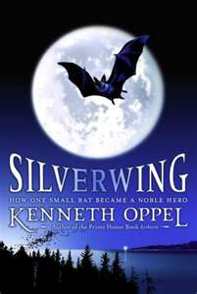

MY READING RESPONSE JOURNAL

Student: __________________________

A reading response journal is a writing exercise where you respond to whatever text you’re reading (a story, poem, song, novel, etc.) in some sort of personal way. You look at the ideas, images, and feelings the text has inspired in you, and you write about it in a journal form. You do have some choice, however…

You might want to directly respond to the text, discussing on paper exactly what you’ve read and the thoughts it has created in your mind. This is usually called a “reflection.”

On the other hand, you might want to create a related response, where you use what you’ve read as inspiration for your own, personal interpretation of the text (sort of your own version, but using the same ideas). There are usually topics given, to help you with creating your own related response.

Chapter One: Shade

READING RESPONSE JOURNAL 1:

Consider the following Reading Response Journal topics for Chapter 1:
 Man, I hate that bully!
 When I get bigger…
 The bond between a mother and child…
 How I fell for temptation…
 Making wise choices…

You may use one of the topics above for your Reading Response Journal, or write a reflection on chapter one and your feelings about it. Remember to use all your best writing skills (including form, voice, word choice, ideas, sentence fluency, and point of view).

BRAINSTORMING (Plan your writing here):

________________________________________________________________________________________________________________________________________________________________________________________________________________________________________________________________________________________________________________________________________________________________________________________________________________________________________________________________________________________________________________________________________________________________________________________________________________________________________________________________________________________________________

Chapter Four: Ablaze
READING RESPONSE JOURNAL 2:

IN THEIR OWN WORDS

Dear Journal…

Have you ever felt like Shade does in this chapter; like the world is falling apart and it’s all your fault? Perhaps you’ve felt like his mother, Ariel, fighting for something and missing what you’ve lost, or Frieda, in charge at a time of crisis.

Imagine you are one of the characters in this chapter. Think about all that you’re feeling, and how you would best express it.
- What word choices would you make?
- What kind of sentences would you use?
- How would the reader know what you were really feeling?

In the voice of the character you’ve chosen, write a brief journal about your experiences at Tree Haven during the fire. Use the details in the story, but add your own ideas and “voice” to make your character come alive. Remember to follow the conventions of journal writing as well!

BRAINSTORMING (Plan your writing here):

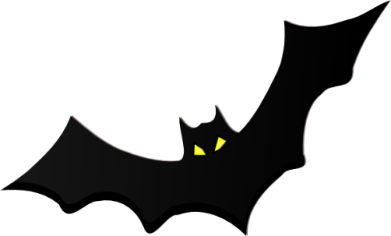

________________________________________________________________________________________________________________________________________________________________________________________________________________________________________________________________________________________________________________________________________________________________________________________________________________________________________________________________________________________________________________________________________________________________________________________________________________________________________________________________________________________________________________________________________________________________________________________________________________________________________________________________________________________________________________________________________________________________________________________________________________________________________________________________________________________________________________________________________________________________________________________________________________________________________________________________________
Chapter Six: Marina

READING RESPONSE JOURNAL 3:

I CAN RELATE!

This Reminds Me of the Time…

Shade and Marina have both experienced some pretty rough times. Can you relate with how they’re feeling? Have you ever been in a similar situation, or felt the same way?

Write a brief account of a time when you’ve felt like Shade or Marina, and remember to relate your experiences back to theirs.

BRAINSTORMING (Plan your writing here):

______________________________________________________________________________________________________________________________________________________________________________________________________________________________________________________________________________________________________________________________________________________________________________________________________________________________________________________________________________________________________________________________________________________________________________________________________________________________________________________
____________________________________________________________________________________________________________________________________________________________________________________________________________________________________________________________

Chapter Twelve: Closed Skies

READING RESPONSE JOURNAL 4:

In this reading response journal, you can once again do a pure “reflection” on the book so far, including your thoughts about events and characters in the story, or you can do a “related response,” writing your own reading response journal based on one of the topics below. It’s your choice!

Reading Response Journal topics for Chapter 12:
 Out of the frying pan and into the fire!
 A wolf in sheep’s clothing…

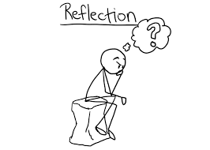

BRAINSTORMING (Plan your writing here):

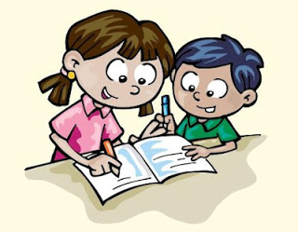

___________________________________________________________________________________________________________________________________________________________________________________________________________________________________________________________________________________________________________________________________________________________________________________________________________________________________________________________________________________________________________________________________________________________________________________________________________________________________________________________________________________________________________________________________________________________________________________________________________________________________________________Chapter Seventeen: Wolf Ears

FILE A MISSING “PERSON’S” REPORT

Have You Seen This Character?

Using the form below, create a “missing person’s” report for one of the characters in the book (Goth, Shade, Throbb, Scirocco, Marina, Ariel, Cassiel, etc.). Include the details you know that will help locate this character: last known location, physical characteristics, identifying traits, habits, any known information, etc

MISSING

Details:
____________________________________________________________________________________________________________________________________________________________________________________________________________

MAKE A PREDICTION

READING RESPONSE JOURNAL 5:

Well, I Think…

What do you suppose is going to happen in the next book, given the events at the close of this one? What do you expect will occur in the next part of the story?
Using your best writing form (voice, word choice, ideas, conventions, organization and sentence fluency), draft a written prediction of at least five paragraphs, outlining what you expect to happen in the next novel and why. Make sure you include your reasoning, in order to get full marks! You can use the space below to organize your thoughts and predictions first:

____________________________________________________________________________________________________________________________________________________________________________________________________________________________________________________________________________________________________________________________________________________________________________________________________________________________________________________________________________________________
________________________________________________________________________________________________________________________________________________________________________________________________________________________________________________________________________________________________________________________________________________________________________________________________________________________

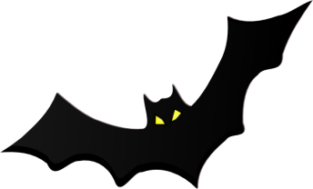
WHEN YOU HAVE COMPLETED THE JOURNAL ACTIVITIES DO THESE PUZZLES. Not for credit.

Puzzling Words

The Journey Begins
T Q D A R I E L M E R C U R Y
S I A E G U Y N O L O C E Y M
O P R N G N N L O T U B I R L
O R P I R N O T K T M H O L D
R O F A P U I B E A S T S O S
C M D B S S T W H B S O C T G
H I B E R N A C U L U M A I R
I S I H H I R P O O W L S U O
N E R S Q S G O I N A R S Q U
O L D H U L I H B C N H I S N
O D S T J A M N T W T R E O D
K E U A E N L I A W E U L M E
W R J B P D T A O B I E R Y D
B S F R I E D A H S G N N E E
S G S S I L V E R W I N G W S

ARIEL CHINOOK CHAMBER CASSIEL BRUTUS

BANISHED BATHSHEBA BATTLE BEASTS BIRDS

BOAT BONG BRIGHTWING COLONY ELDERS

FRIEDA HIBERNACULUM GROUNDED HOLD ISLAND

MERCURY MIGRATION MOSQUITO MOTH OWLS

NEWBORNS NOCTURNA PICTURES PROMISE ROOST

RUNT SILVERWING SHADE SPIRIT STONE

STORM STALACTITE SUN WINGED
Puzzling Words
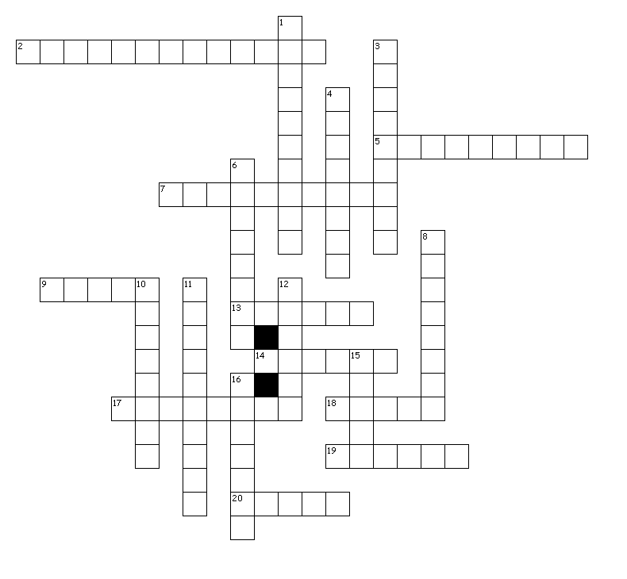

Across

2. final landmark
5. fan's effect
7. using sound to see
9. eye Goth's echo
13. weak prisoner
14. Goth's first victim
17. Shade's god
18. top for a church
19. Zephyr's pigment
20. runt of the litter

Down

1. a punishment
3. prejudiced bats
4. eats its own kind
6. a quick snack
8. church guardian
10. Goth's god(2 WORDS)
11. a fast way to fly
12. chief elder
15. the author
16. circle of light

Puzzling Words

Becoming Human?
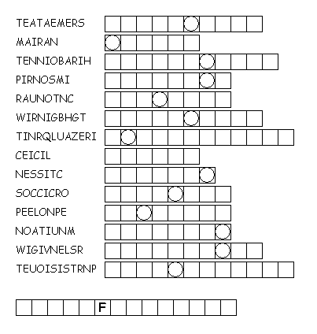
Unscramble each of the clue words.
Take the letters that appear in boxes and unscramble them for the final message.

Puzzling Words

Escape to Hibernaculum

