Formatting Your Paper in MLA using Microsoft Word
http://www.lib.usm.edu/legacy/tutorials/mlatutorial/formatview.php

Set up Running Name and Page Number in Upper Right:

Option 1:

Step 1 – Select Insert > Page # > Top of Page > Plain #3 > Then type in your surname (last name) in front of the 1

Step 2 – Select Page # > Format Page Numbers > OK

Step 2 – SAVE

OR

Option 2:
Step 1 - Select View > Header and Footer
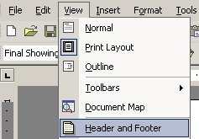
Step 2 - Type your last name, space, then click on the page number icon to insert the page number.
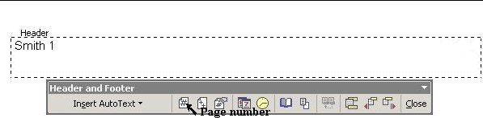
Step 3 - Align to the right by clicking on the "Align Right" icon on the top toolbar. Then close the "Header and Footer" toolbar.
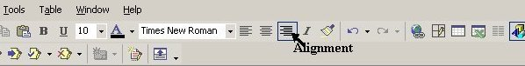

Set up 1" Margins:
Step 1 - Select File > Page Setup...  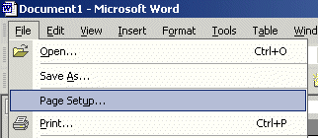 | Step 2 - Specify 1" Top, Bottom, Left, Right in Margins  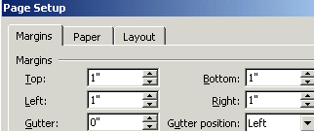

Set up Double Spacing:
Step 1 - Select Format > Paragraph
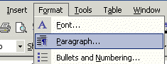
Step 2 - Find "Line Spacing" and select "Double" from the drop down menu.
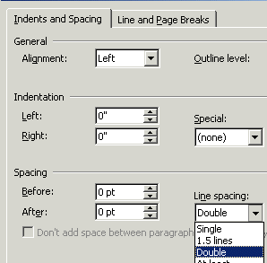

Beginning your Paper - Heading and Title

- Now that you are formatted correctly, type your heading - type your name, professor's name, the course number and the date (on separate lines).
- Double space, center and type the title of your paper (it's okay to have a title which runs onto more than one line).
- Double space again and begin typing the first paragraph of your paper. Remember to indent (tab) the first line of each paragraph.

First page of a sample essay
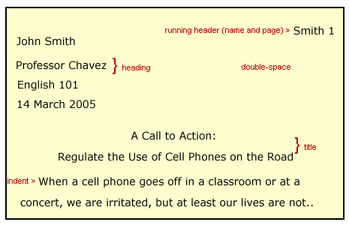

To Make a Hanging Indent

To make a hanging indent using MS Word, highlight the whole entry, go to the top toolbar and select Format Paragraph Indentation Special dropdown menu choose Hanging

