English 2201 Analysis of Visuals

Visual/Artistic Elements

- Angle: space between diverging lines; part that sticks out; position from which something may be viewed. The slant, or direction of looking at or presenting something.

- Asymmetry: lacking equality, balance, or harmony; not regularly arranged on opposite sides of a line or around a central point

- Background: the part of a picture or pattern that appears to be in the distance or behind the most important part

- Balance: the degree to which elements of a picture are in proportion. If the elements are balanced, there is harmony. If they are weighted to one side, there is tension.

Symmetrical | Asymmetrical | Radial
Equal distribution of design | More work on one side than the other. | Central focal point

- Blank space (white space): unused space in an illustration. It helps to create contrast with shapes and colours in the illustration, helps to define a focal point (what the eye is drawn to), and makes the viewer question what is missing.

- Composition: The arrangement of visual elements within a picture (layout of the elements)

- Colour: creates contrast and emphasis (i.e. a bright colour on a drab background), can have symbolic meaning (green = nature), and can suggest a mood (black = depressing, scary).

- Meaning of Colour:

  - Red: energy, excitement, emotion, danger (fire trucks, exit signs), passion. It’s always intense and demands to be noticed.
  - Pink: happy and carefree.
  - Orange: warm, active, contemplative, soft.
  - Yellow: energetic, bright, with a light quality.
  - Green: environment, sickness, poison, has taken on a very strong connotation as the color representing ecology and concern for the environment, however, it also conveys meanings associated with money and the suggestion "to go ahead" which is obviously derived from traffic lights.
  - Blue: contemplative, hopeful, deep, the color of surprises, harmony.
  - Violet: royalty, mysticism, passion.
  - Brown: earth, life, growth/decay.
  - Black: drama, death, elegance, seriousness, sophistication and formality.
  - White: innocence, life and purity
  - Purple and gold: often associated with Royalty, wealth and opulence.
  - Red, White reminiscent of the Canadian flag, immediately convey notions of patriotism and, to some extent, conservatism.
  - Colors represent holidays and seasons of the year: The Fall foliage colors of Red, orange, yellow, and brown are clearly expressive of Thanksgiving. Halloween: Orange and Black. Red and Green represent Christmas. Purple and Yellow and other pastels colors represent Easter.
  - Blue, Red, White and Grey: Stability, Power, Trustworthiness, Conservatism
  - Yellow, Brown, Orange, Green: Nature, earthiness, warmth
  - Red, Orange, yellow: more warmth
  - Blues and Aquas: water and coolness
  - Primary colors (Red, Blue, Yellow): fun

- Contrast: created by two elements of the visual that are different (black-white, large-small, etc.). Creates emphasis.

- Dominant Image: more important, effective, or prominent than others

- Emphasis: Drawing attention to something by use of color, size or placement

- Focal Point: where the eye is drawn in a visual – contrast or an unusual image can create a focal point.

- Focus (in or out): the quality that makes an image sharply defined with clear edges and contrast

- Font: style and size of type

- Foreground: the part of a picture or scene that appears nearest the viewer

- Frame: a structure that surrounds or encloses a particular space

- Harmony: The quality that binds the parts of a visual image into a while. It is often created through simplicity and repetition

- Juxtaposition: the act or an instance of placing two or more things side by side

- Lighting: the amount or type of light in a photograph, painting, or other artwork

- Line: lines frame pictures, draw the eye to the focal points and create contrasts. Curved lines suggest softness; angular lines suggest hardness; jagged lines suggest energy.

  - Horizontal line: suggests a feeling of calmness, rest or repose.
  - Vertical lines communicate a feeling of loftiness and spirituality. Erect lines seem to extend upwards beyond human reach, toward the sky.
  - Horizontal and vertical lines in combination communicate stability and solidity.
  - Diagonal lines suggest a feeling of movement or direction. Thus if a feeling of movement or speed is desired, or a feeling of activity, diagonal lines can be used.
  - Curved lines do vary in meaning. Soft, shallow curves suggest comfort, safety, familiarity, relaxation. Deep, acute curves, on the other hand, suggest confusion, turbulence, even frenzy, as in the violence of waves in a storm, the chaos of a tangled thread, or the turmoil of lines suggested by the forms of a crowd.
  - Repeating Lines: create unity.
  - Directional Lines: create emphasis.
  - Thin Lines: suggest softness.
  - Thick Lines: suggest emphasis.
  - Wavy, Curvy, Jagged Lines: suggest movement.
  - Jagged Lines: anxious.

- Movement: A sense of energy in a visual, determined by the spaces between shapes and by the shapes themselves

- Panel: a section depicting a single scene in a comic strip

- Perspective: the appearance of objects to an observer allowing for the effect of their distance from the observer

- Proportion: the correct or desirable relationship of size, quantity, or degree between two or more things or parts of something

- Pose: a living thing’s body position can suggest a lot about its state of mind. Pay close attention to facial expression and body language.

- Scale: a ratio representing the size of an illustration or reproduction, especially a map or a model, in relation to the object it represents

- Shadow: a darkened shape on a surface that falls behind somebody or something blocking the light

- Symbol: covered in previous notes, it still remains that a symbol is a person, place, or object which stands for or represents an abstract thought or idea i.e. the Canadian flag represents our country, its people, its ideas and its history

- Symmetry: the property of being the same or corresponding on both sides of a central dividing line; the harmony and beauty that results from such balance

- Words (text): words should be analyzed for font (i.e. is it in a childish form of writing, or is it more sophisticated?) and also for connotation (extra meanings a word comes to have.)

FORMS

- Caricature - a drawing, description, or performance that exaggerates somebody's or something's characteristics for humorous or satirical effect (Political Cartoons)

- Collage- a picture made by sticking cloth, pieces of paper, photographs, and other objects onto a surface i.e. see my right wall

- Comic Strip - a series of cartoons that tell a story or a joke i.e. Garfield, Peanuts, Cathy, For Better For Worse are my favorites

- Editorial Cartoon - a cartoon that appears in the editorial section of a newspaper, using humour to criticize a serious issue in the news

- Graphics - the presentation of information in the form of diagrams and illustrations instead of as words or numbers

- Photo essay - a collection of photographs in a magazine or book (or English project), often accompanied by a short commentary, that provide an overview

- Poster - a printed picture, often a reproduction of a photograph or artwork, used for decoration or advertisement

- Print - a work of art made by inking a surface with a raised design and pressing it onto paper or another surface

- Storyboard - a set of sketches, arranged in sequence on panels, outlining the scenes that will make up something to be filmed, e.g., a motion picture, television show, or advertisement

- Other Important Terminology:

- Audience: whom is the artist aiming the message at?
- Context: the situation in which an image appears.
- Effect: What is created as a result?
- Message: any thought, idea, or information, whether expressed in plain or in secret language, prepared in a form suitable for transmission by any means of communication.
- Mood: Be aware of the overall feeling suggested by all of these elements.
- Motive: reason for doing something.
- Purpose or intent: the reason the artist had for creating the text. What message is the artist trying to get across?
- Title: what would be an appropriate title for an image? Should include some figurative significance, literary device or connotation based on subject.
English 2201 Visual Deconstruction

Evaluating Visuals:

Step One: Examine the visual as a whole. Ask Yourself:
- Does it appeal to me? Why or why not?
- What is the subject of the work?
- How does the visual make you feel?
- What is the overall tone/mood/atmosphere of the visual?
- What message is being relayed by the visual?
- What is the title? How does it relate to the visual?

Step Two: Closely examine the visual for elements of tone/mood/atmosphere. Ask Yourself:
- Why do I think this tone/mood/atmosphere is ____________?
- Do the colors used have anything to do with it?
- What about the positioning of the subject matter?
- Do the characters have expressions on their faces?
- Is there anything that suggests movement?
- What shapes has the artist used? Curved? Geometric? Linear?
- What about the lines in the visual? Are they thick, thin, straight, curved, vertical, horizontal, diagonal?
- How does the artist manipulate space? Are the elements primarily in the foreground or the background? Is space minimally or maximally used?

Step Three: View the visual with respect to aesthetics. Ask yourself:
- Is the work balanced? Is it symmetrical, asymmetrical or radial?
- Does anything catch your eye (dominant impression)? What is it? Why does it catch your eye?
- Examine the setting. Is it day? Night? Inside? Outside? City? Country? Etc.
- From what viewpoint is the visual taken? High? Low?
- Has the artist used juxtaposition?
- Has the artist used contrast? (light/dark, rough/smooth, bold/timid, warm/cool, straight/curved, shiny/dull, plain/patterned)
- Where has the artist placed emphasis?

Step Four: Put it in perspective. Ask yourself:
- Does this visual remind me of anything? Allusions?
- Is there any text (labels, titles, captions)? How does it enhance the visual?
- Are there any symbols? What do they represent? Do they enhance the visual?
- What purpose could the artist have had in mind when creating this visual?
- Is there a unity to the visual?
- Is there an intended audience? If so, who is it?

Artistic Visuals

A visual is an item that uses images to convey information and meaning. Visuals do not necessarily use WORDS to send messages, but they often use other elements not found in “regular” texts to create emotion, send a message, entertain or amuse the audience or make them think.

Like other texts, visuals are created purposefully, with an intended theme or message, an intended audience, a desired tone, and a certain mood or atmosphere. They may also use elements of conflict, irony, character, --- all the things that we usually associate with stories or poems.
Analyzing a Visual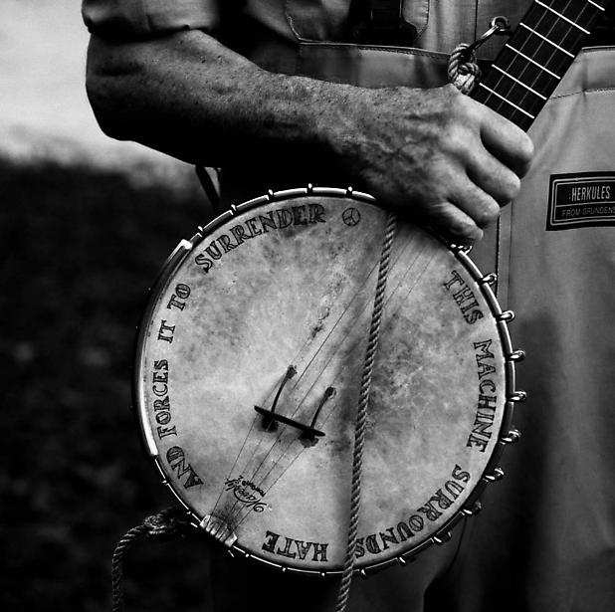

The focal point of this image is the banjo – if you took the banjo out of the picture, the meaning and purpose would change. The banjo is also the thing that the artist wants you to focus on, that's why it's called the focal point. Generally speaking, the focal point will be the most important part of the image – the audience (you) is meant to focus on it!

A theme or main idea of this visual could be: music is very powerful. On the banjo the words that read: “THIS MACHINE SURROUNDS HATE AND FORCES IT TO SURRENDER”

So, how does this equal music is powerful?
- a banjo, a musical instrument, is powerful enough to force hatred to surrender.
- Hatred is “killed” by music.
- Think of all the songs you know that centre around the idea of peace (ex: “Where is the Love?” - Black Eyed Peas, “21 Guns” – Green Day, “Jesus Walks” – Kanye West, “Square Dance” – Eminem, “Worldwide Suicide” – Pearl Jam – etc., etc., etc.,) the messages in these songs are aimed at promoting peace and ridding the world of violence and hatred.
- If a single banjo is enough of a “machine” to help kill hatred, it's a pretty powerful weapon, indeed!

Another possible theme for the visual could be that: “To stop hatred in the world, we don't need more weapons, we need more music”

There is an atmosphere being created in the visual. When you are asked to identify atmosphere the first question you should ask yourself is “How does this make me feel?” or “How does the artist want me to feel when I see this?”
In this image, the atmosphere is powerful or strong. The artist wants to empower the audience and make them feel strong. Some clues to identifying the atmosphere:
- the man's strong arms – big muscles usually mean strength and power
- the words “surround” “forces” and “surrender” are all powerful words. It takes strength to surround another person and force them to surrender.
- the use of black and white, instead of colour in the visual also sends a strong message
- the word “Herkules” is on the man's coveralls. Hercules is a Greek hero who was famous for – you guessed it! His strength!

There is a definite tone in this visual. When you are asked to identify tone, the first question you should ask yourself is “How does the artist who made this visual feel about what they are saying?” This type of question is a little harder to answer. You have to put yourself in the author's shoes: How would I have to be feeling to make an image like this? (You should already have a list of tone vocabulary words – if you don't, please see me.)

Does the artist feel happy? Sad? Angry? Bored? Neutral (no feelings), embarrassed? Lonely? Silly? Why or why not?

A possible tone of this visual is serious, passionate, or reminiscent.

Is there conflict in the “banjo” visual? You could argue that the Banjo appears to be dirty which suggests that it had been through some “dirty” experiences. It has been well used and has seen and experienced a great deal.

Some other questions we could ask about the “Banjo” image are:
- Suggest a title for this image. Support your ideas with references to the visual.
- What is the theme or message of this visual? Support with references to the visual.
- What is the tone of this visual? Support with references to a visual element as well as a textual element.

Visual #1

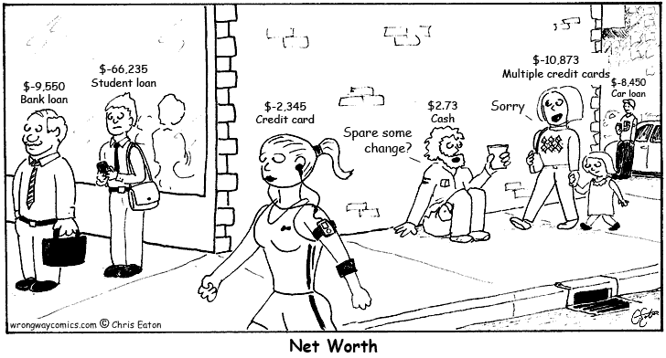

Explain the effectiveness of the title “Net Worth” using two visual elements for support.

Visual #2

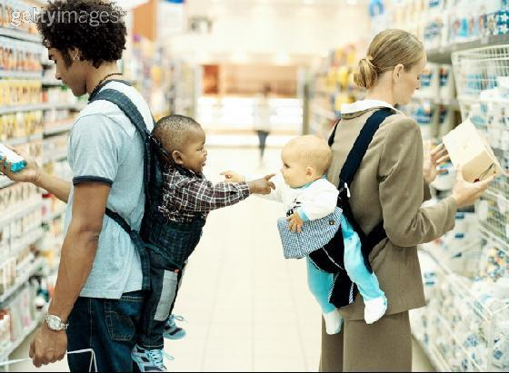

State a theme for this visual and support your answer with reference to two specific visual elements.

Visual #3

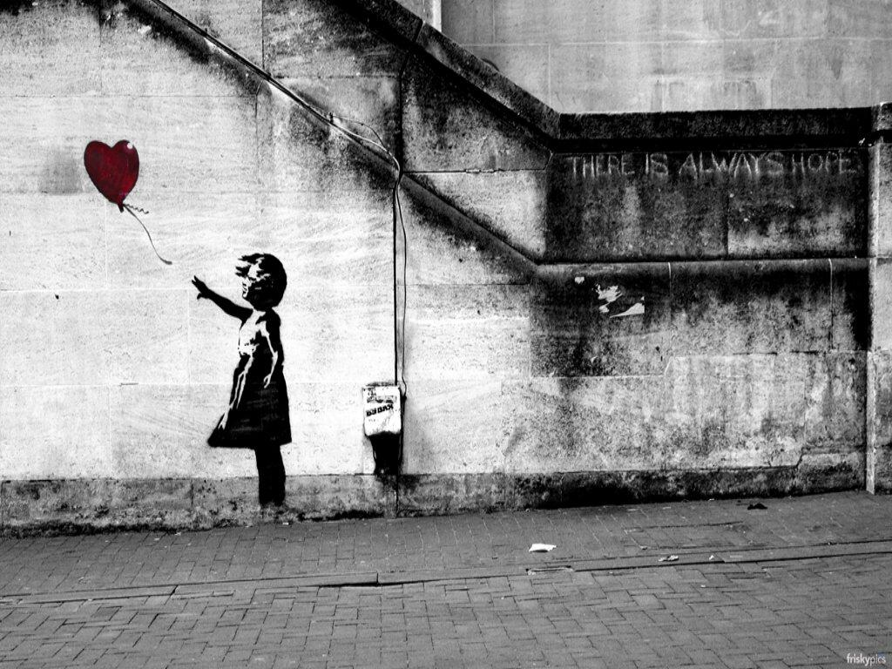

1. What type of image is this?

- How would you entitle this visual? Why?

- What is the focal point of the image?

- Is there balance in the image?

- What kinds of lines are used in the image? What do they indicate?

- What is the mood of the image? What visual elements contribute to this mood?

Visual #4
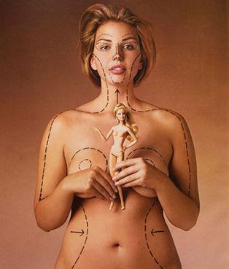

State a theme for the visual and support your response with reference to two specific visual elements.

Visual #5

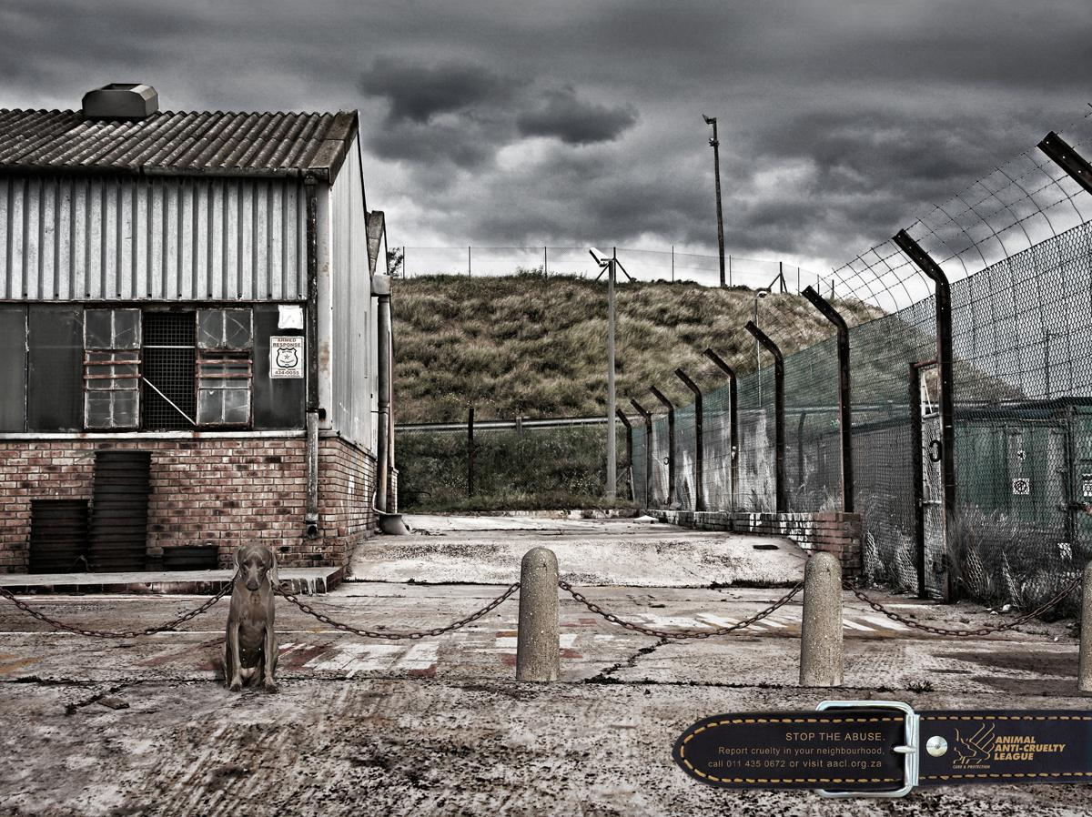

Identify the mood of this visual. Use two specific visual elements to show how they are used effectively to create the mood.

Visual #6

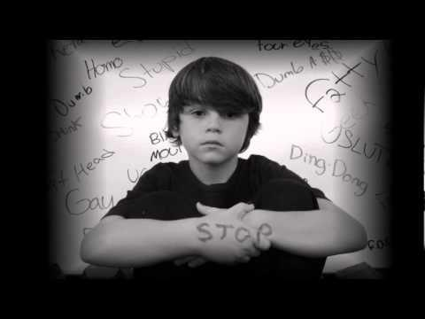

1. What is the focal point of the image?
  - The boys face
  - The word “stop”
  - The black boarder
  - The words “fatty”, “dumb”, “stupid”

- What type of image is this?
  - A photograph
  - A painting
  - A comic strip
  - A caricature

- What is the intent of the image?
  - To educate
  - To entertain
  - To persuade
  - To criticize

- What is the mood of the visual?
  - Nostalgic
  - Solemn
  - Humorous
  - Lighthearted

- What is the message of the visual? Use two visual elements for support.

Visual #7

State a theme for the visual and support your response with reference to two specific visual elements.

