**English 1201 Analysis of Visuals**

**Visual/Artistic Elements**

* **Angle:** space between diverging lines; part that sticks out; position from which something may be viewed. The slant, or direction of looking at or presenting something.
* **Asymmetry:** lacking equality, balance, or harmony; not regularly arranged on opposite sides of a line or around a central point
* **Background:** the part of a picture or pattern that appears to be in the distance or behind the most important part
* **Balance**: the degree to which elements of a picture are in proportion. If the elements are balanced, there is *harmony*. If they are weighted to one side, there is *tension*.

|  |  |  |
| --- | --- | --- |
| ***Symmetrical*** | ***Asymmetrical*** | ***Radial*** |
|  | *MCj03194520000[1]* | *MCj03528580000[1]* |
| ***Equal distribution of design*** | ***More work on one side than the other.*** | ***Central focal point*** |

* **Blank space (white space):** unused space in an illustration. It helps to create *contrast* with shapes and colours in the illustration, helps to define a *focal point* (what the eye is drawn to), and makes the viewer question what is missing.
* **Composition:** The arrangement of visual elements within a picture (layout of the elements)
* **Colour**: creates contrast and *emphasis* (i.e. a bright colour on a drab background), can have symbolic meaning (green = nature), and can suggest a mood (black = depressing, scary).

# Meaning of Colour:

* **Red:** energy, excitement, emotion, danger (fire trucks, exit signs), passion. It’s always intense and demands to be noticed.
* **Pink:** happy and carefree.
* **Orange:** warm, active, contemplative, soft.
* **Yellow:**  energetic, bright, with a light quality.
* **Green:** environment, sickness, poison, has taken on a very strong connotation as the color representing ecology and concern for the environment, however, it also conveys meanings associated with money and the suggestion "to go ahead" which is obviously derived from traffic lights.
* **Blue:** contemplative, hopeful, deep, the color of surprises, harmony.
* **Violet:** royalty, mysticism, passion.
* **Brown:**  earth, life, growth/decay.
* **Black:** drama, death, elegance, seriousness, sophistication and formality.
* **White:** innocence, life and purity
* **Purple and gold:** often associated with Royalty, wealth and opulence.
* **Red, White** reminiscent of the Canadian flag, immediately convey notions of patriotism and, to some extent, conservatism.
* **Colors represent holidays and seasons of the year:** The Fall foliage colors of Red, orange, yellow, and brown are clearly expressive of Thanksgiving. Halloween: Orange and Black. Red and Green represent Christmas. Purple and Yellow and other pastels colors represent Easter.
* **Blue, Red, White and Grey:** Stability, Power, Trustworthiness, Conservatism
* **Yellow, Brown, Orange, Green**: Nature, earthiness, warmth
* **Red, Orange, yellow**: more warmth
* **Blues and Aquas:** water and coolness
* **Primary colors (Red, Blue, Yellow)**: fun
* **Contrast**: created by two elements of the visual that are different (black-white, large-small, etc.). Creates *emphasis*.
* **Dominant Image:** more important, effective, or prominent than others
* **Emphasis:** Drawing attention to something by use of color, size or placement
* **Focal Point:** where the eye is drawn in a visual – contrast or an unusual image can create a focal point.
* **Focus (in or out)**: the quality that makes an image sharply defined with clear edges and contrast
* **Font:** style and size of type
* **Foreground**: the part of a picture or scene that appears nearest the viewer
* **Frame:** a structure that surrounds or encloses a particular space
* **Harmony:** The quality that binds the parts of a visual image into a while. It is often created through simplicity and repetition
* **Juxtaposition**: the act or an instance of placing two or more things side by side
* **Lighting:** the amount or type of light in a photograph, painting, or other artwork
* **Line**: lines frame pictures, draw the eye to the focal points and create contrasts. *Curved lines* suggest softness; *angular lines* suggest hardness; *jagged lines* suggest energy.
* **Horizontal** **line:** suggests a feeling of calmness, rest or repose.
* **Vertical** **lines** communicate a feeling of loftiness and spirituality. Erect lines seem to extend upwards beyond human reach, toward the sky.
* **Horizontal and vertical lines in combination** communicate stability and solidity.
* **Diagonal lines** suggest a feeling of movement or direction. Thus if a feeling of movement or speed is desired, or a feeling of activity, diagonal lines can be used.
* **Curved lines** do vary in meaning. **Soft, shallow curves** suggest comfort, safety, familiarity, relaxation. **Deep, acute curves**, on the other hand, suggest confusion, turbulence, even frenzy, as in the violence of waves in a storm, the chaos of a tangled thread, or the turmoil of lines suggested by the forms of a crowd.
* Repeating Lines: create unity.
* Directional Lines: create emphasis.
* Thin Lines: suggest softness.
* Thick Lines: suggest emphasis.
* Wavy, Curvy, Jagged Lines: suggest movement.
* Jagged Lines: anxious.
* **Movement:** A sense of energy in a visual, determined by the spaces between shapes and by the shapes themselves
* **Panel:** a section depicting a single scene in a comic strip
* **Perspective:** the appearance of objects to an observer allowing for the effect of their distance from the observer
* **Proportion:** the correct or desirable relationship of size, quantity, or degree between two or more things or parts of something
* **Pose**: a living thing’s body position can suggest a lot about its state of mind. Pay close attention to facial expression and body language.
* **Scale:** a ratio representing the size of an illustration or reproduction, especially a map or a model, in relation to the object it represents
* **Shadow:** a darkened shape on a surface that falls behind somebody or something blocking the light
* **Symbol:** covered in previous notes, it still remains that a symbol is a person, place, or object which stands for or represents an abstract thought or idea i.e. the Canadian flag represents our country, its people, its ideas and its history
* **Symmetry:** the property of being the same or corresponding on both sides of a central dividing line; the harmony and beauty that results from such balance
* **Words (text)**: words should be analyzed for *font* (i.e. is it in a childish form of writing, or is it more sophisticated?) and also for *connotation* (extra meanings a word comes to have.)

**FORMS**

* **Caricature** - a drawing, description, or performance that exaggerates somebody's or something's characteristics for humorous or satirical effect
* **Collage**- a picture made by sticking cloth, pieces of paper, photographs, and other objects onto a surface i.e. see my right wall
* **Comic Strip** - a series of cartoons that tell a story or a joke i.e. Garfield, Peanuts, Cathy, For Better For Worse are my favorites
* **Editorial Cartoon** - a cartoon that appears in the editorial section of a newspaper, using humour to criticize a serious issue in the news
* **Graphics** - the presentation of information in the form of diagrams and illustrations instead of as words or numbers
* **Photo essay** - a collection of photographs in a magazine or book (or English project), often accompanied by a short commentary, that provide an overview
* **Poster** - a printed picture, often a reproduction of a photograph or artwork, used for decoration or advertisement
* **Print** - a work of art made by inking a surface with a raised design and pressing it onto paper or another surface
* **Storyboard** - a set of sketches, arranged in sequence on panels, outlining the scenes that will make up something to be filmed, e.g., a motion picture, television show, or advertisement

**Other Important Terminology:**

1. **Audience**: whom is the artist aiming the message at?
2. **Context:** the situation in which an image appears.
3. **Effect:** What is created as a result?
4. **Message:** any thought, idea, or information, whether expressed in plain or in secret language, prepared in a form suitable for transmission by any means of communication.
5. **Mood**: Be aware of the overall feeling suggested by all of these elements.
6. **Motive:** reason for doing something.
7. **Purpose or intent**: the reason the artist had for creating the text. What message is the artist trying to get across?
8. **Title:** what would be an appropriate title for an image? Should include some figurative significance, literary device or connotation based on subject.

**English 1201**

**Visual Deconstruction**

**Evaluating Visuals:**

**Step One: Examine the visual as a whole. Ask Yourself:**

1. Does it appeal to me? Why or why not?
2. What is the subject of the work?
3. How does the visual make you feel?
4. What is the overall tone/mood/atmosphere of the visual?
5. What message is being relayed by the visual?
6. What is the title? How does it relate to the visual?

**Step Two: Closely examine the visual for elements of tone/mood/atmosphere. Ask Yourself:**

1. Why do I think this tone/mood/atmosphere is ____________?
2. Do the colors used have anything to do with it?
3. What about the positioning of the subject matter?
4. Do the characters have expressions on their faces?
5. Is there anything that suggests movement?
6. What shapes has the artist used? Curved? Geometric? Linear?
7. What about the lines in the visual? Are they thick, thin, straight, curved, vertical, horizontal, diagonal?
8. How does the artist manipulate space? Are the elements primarily in the foreground or the background? Is space minimally or maximally used?

**Step Three: View the visual with respect to aesthetics. Ask yourself:**

1. Is the work balanced? Is it symmetrical, asymmetrical or radial?
2. Does anything catch your eye (dominant impression)? What is it? Why does it catch your eye?
3. Examine the setting. Is it day? Night? Inside? Outside? City? Country? Etc.
4. From what viewpoint is the visual taken? High? Low?
5. Has the artist used juxtaposition?
6. Has the artist used contrast? (light/dark, rough/smooth, bold/timid, warm/cool, straight/curved, shiny/dull, plain/patterned)
7. Where has the artist placed emphasis?

**Step Four: Put it in perspective. Ask yourself:**

1. Does this visual remind me of anything? Allusions?
2. Is there any text (labels, titles, captions)? How does it enhance the visual?
3. Are there any symbols? What do they represent? Do they enhance the visual?
4. What purpose could the artist have had in mind when creating this visual?
5. Is there a unity to the visual?
6. Is there an intended audience? If so, who is it?

**Artistic Visuals**

**Visual #1**

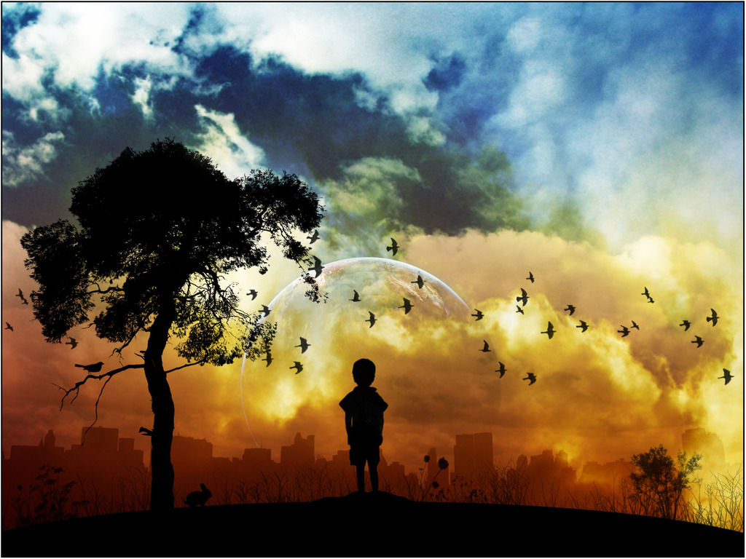

1. What type of image is this?

__________________________________________________________________________

1. How would **you entitle this visual**? Why?

___________________________________________________________________________

1. What is the **focal point** of the image?

___________________________________________________________________________

1. Is there **balance** in the image? How is it created?

___________________________________________________________________________  
___________________________________________________________________________

1. D*oes it provide* ***contrast****? How?*

___________________________________________________________________________  
___________________________________________________________________________

1. What kinds of **lines** are used in the image? What do they indicate?

___________________________________________________________________________  
___________________________________________________________________________

1. What is the **mood** of the image? What visual elements contribute to this mood?

___________________________________________________________________________  
___________________________________________________________________________  
___________________________________________________________________________

1. Write a theme statement for this image.

___________________________________________________________________________  
___________________________________________________________________________

**Visual #2**

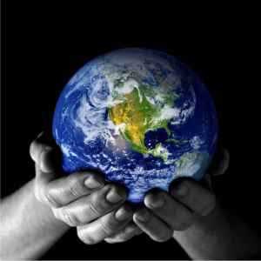

1. What type of image is this?
   1. Advertisement
   2. Caricature
   3. Cartoon
   4. Poster
2. What is the dominant visual element used in this image?
   1. Line
   2. Scale
   3. Color
   4. Perspective
3. What is the **focal point** of the image?

___________________________________________________________________________

1. Identify the message using two visual elements for support.

____________________________________________________________________________________________________________________________________________________________________________________________________________________________________________________________________________________________________________________________________________________________________________________________________________________________________________________________________________________________________________________________________________________________________________________________________________________________________________________________________________________________________________________________________________________________________________________________________________________________________________________________________________________________________________________________________________________________________________________________________________________________________________________________________________________________________________________________________________________________________________________________________________________________________________________________________________________________________________________________________________________________________________________________________________________________________________________________

**Visual #3**



State a theme for this visual and support your answer with reference to two specific visual elements.

______________________________________________________________________________________________________________________________________________________________________________________________________________________________________________________________________________________________________________________________________________________________________________________________________________________________________________________________________________________________________________________________________________________________________________________________________________________________________________________________________________________________________________________________________________________________________________________________________________________________________________________________________________________________________________________________________________________________________________________________________________________________________________________________________________________________________________________________________________________________________________________________________________________________________________________________________________________________________________________________________________________________________________________________________________________________________________________________________________________________________________________________________________________________________________________________________________________________________________________________________________________________________________________________________________________________________________________________________________________________________________________________________________________________________________________________________________________________________________________________________________________________

**Visual #4**

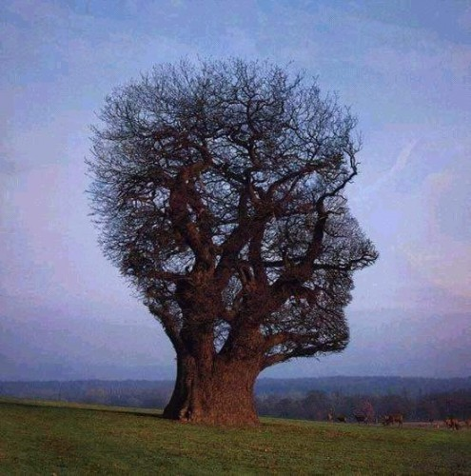

State a theme for this visual and support your answer with reference to two specific visual elements.

____________________________________________________________________________________________________________________________________________________________________________________________________________________________________________________________________________________________________________________________________________________________________________________________________________________________________________________________________________________________________________________________________________________________________________________________________________________________________________________________________________________________________________________________________________________________________________________________________________________________________________________________________________________________________________________________________________________________________________________________________________________________________________________________________________________________________________________________________________________________________________________________________________________________________________________________________________________________________________________________________________________________________________________________________________________________________________________________________________________________________________________________________________________________________________________________________________________________________________________________________________________________________________________________________________________________________________________________________________________________________________________________________________________________________________________________________________________________________________________________________________________________________________________________________________________________________________

**Visual #5**

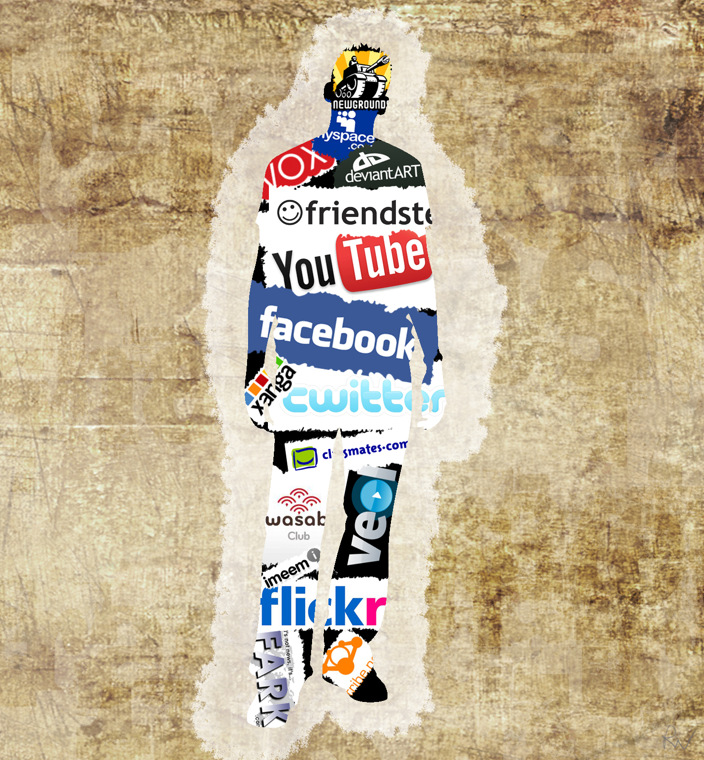

State a title for the visual and support your response with reference to two visual elements.

____________________________________________________________________________________________________________________________________________________________________________________________________________________________________________________________________________________________________________________________________________________________________________________________________________________________________________________________________________________________________________________________________________________________________________________________________________________________________________________________________________________________________________________________________________________________________________________________________________________________________________________________________________________________________________________________________________________________________________________________________________________________________________________________________________________________________________________________________

**Visual #6**

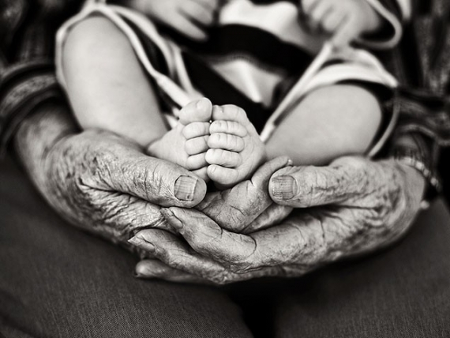

State a theme for the visual and support your response with reference to two specific visual elements.

__________________________________________________________________________________________________________________________________________________________________________________________________________________________________________________________________________________________________________________________________________________________________________________________________________________________________________________________________________________________________________________________________________________________________________________________________________________________________________________________________________________________________________________________________________________________________________________________________________________________________________________________________________________________________________________________________________________________________________________________________________________________________________________________________________________________________________________________________________________________________________________________________________________________________________________________________________________________________________________________________________________________________________________________________________________________________________________________________________________________________________________________________________________________________________________________________________________________________________________________________________________________________________________________________________________________________________________________________________________________________________________________________

**Visual #7**

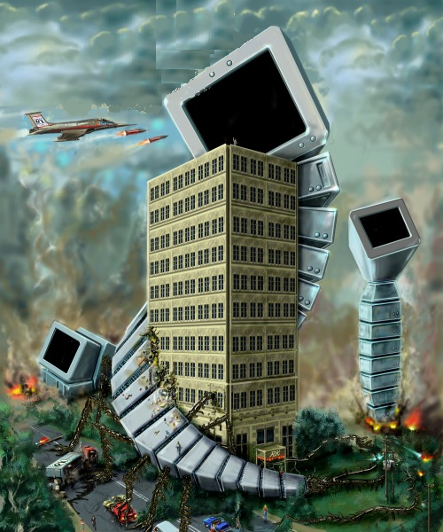

**Selected Response:**

1. What word best describes the emotion conveyed in the visual?
   1. hope
   2. indifference
   3. catastrophe
   4. vulnerability
2. What is the visual promoting?
   1. armed conflict
   2. technological advances
   3. dangers of technology
   4. effects of war
3. What is the purpose of the visual?
   1. to advertise
   2. to describe
   3. to entertain
   4. to inform
4. Which best describes the computers in the visual?
   1. confrontational
   2. hesitant
   3. hard working
   4. determined
5. What is the focal point of the visual?
   1. the air planes
   2. the building
   3. the cloudy sky
   4. the road
6. What purpose does the background serve?
   1. to create scale
   2. to develop texture
   3. to establish perspective
   4. to provide contrast
7. What is the target audience for this visual?
   1. soldiers
   2. children
   3. corporations
   4. adults
8. What best describes the atmosphere of the visual?
   1. sad
   2. indifferent
   3. hostile
   4. sentimental
9. What is the medium of this visual?
   1. collage
   2. cartoon
   3. painting
   4. poster
10. What visual element is most prominent in this visual?
    1. balance
    2. juxtaposition
    3. contrast
    4. focal point

**Constructed Response**

1. Identify the mood of this visual. Use two specific visual elements to show how they are used effectively to create the mood.

____________________________________________________________________________________________________________________________________________________________________________________________________________________________________________________________________________________________________________________________________________________________________________________________________________________________________________________________________________________________________________________________________________________________________________________________________________________________________________________________________________________________________________________________________________________________________________________________________________________________________________________________________________________________________________________________________________________________________________________________________________________________________________________________________________________________________________________________________________________________________________________________________________________________________________________________________________________________________________________________________________________________________________________________________________________________________________________________

1. Provide a title for the image. Explain how this title is supported through two visual elements.

________________________________________________________________________________________________________________________________________________________________________________________________________________________________________________________________________________________________________________________________________________________________________________________________________________________________________________________________________________________________________________________________________________________________________________________________________________________________________________________________________________________________________________________________________________________________________________________________________________________________________________________________________________________________________________________________________________________________________________________________________________________________________________________________________________________________________________________________________________________________________________________________________________________________________________________________________________________________________________________________________________________________________________________________________________________________________________________________________________________________________________________________________________________________________________________________________________________________________________________________________________________________________________________________________________________________________________________________________________________________________________________________________________________________________________________________________________________________________________________________________________________________________________________________________________________________________________________________________________________________________________________________________________________________________________________________________________________________________________________________________________________________________________________________________________________________________________________________________________________________________________________________________________________________________________________________________________________________________________________________________________________________________________________________________________________________________________________________________________________________________________________________________________________________________________________