GRADE SEVEN

POETRY ANALYSIS BOOKLET

STUDENT: _________________________________________

How to Read Poetry

- Look over the entire poem. Does the layout or form of the poem carry some meaning?
Read the title. What does the title suggest? Titles sometimes reveal theme.

- Read the poem all the way through.
What images do you see?
How does the poem make you feel? Why?
What thoughts come to mind as you are reading?
- Read the poem again but very slowly concentrating on the parts that seemed unclear.
Use a dictionary to check unfamiliar words.
Who is the speaker in the poem? Is it the poet? An animal or object?
What is the subject of the poem? How does the speaker feel about the subject of the poem?
Does the poem begin with an event? An act? An idea?
Read the poem a third time, aloud.
Listen to the sounds of the words and how they affect you? Do the sounds add meaning or create a mood?
Look for repeated words. Poets often use repetition to emphasize the main idea or improve the rhythm of a poem.

- Tell what the poem is about in your own words.
What is happening in the poem (literal summary)?
What does the poet or speaker see, think, or feel?
- Connect with the poem. Which feelings, situations, or images remind you of events or emotions in your own life?
Does the poem have a deeper (figurative) meaning? Paying attention to the tone and studying the title of the poem may help reveal theme.

Constructed Response Formats

Mood/Tone
Mood can be very important, but difficult to detect. It relies on the author's description, imagery, and the atmosphere created. It can also be linked to an author's intention and to the tone of a piece of writing.
Mood is used by writers to create an emotional reaction in the reader. The writer creates the mood through details that appeal to the reader's senses. When a writer shows what he/she is experiencing, the reader is going to feel those sensations too.

Writing about Mood/Tone
Pre-writing
Review your definition and decide on a word or phrase that describes the mood/tone you intend to write about in this poem?
What helped you make your decision? What words, phrases, descriptions, etc. influenced your feelings?
Writing the paragraph
Topic sentence
Write a topic sentence which identifies the title, author and genre as well as states the mood of the text.
Body sentences
Define mood/tone and introduce the overall mood/tone of the poem.
Discuss the words, phrases, images, details, etc. that the author used to create the mood/tone in this poem.
Describe how the mood/tone influences you (the reader).
Include reasons why the author would create this particular mood/tone for the poem. What is the subject of the poem? Why is this important?
Concluding sentence

Did the mood/tone help you understand more of the poem? Why?

Imagery
Topic sentence
Write a topic sentence which identifies the title, author and genre as well as states the topic of the paragraph
Body sentences
Define imagery
Quote specific examples of imagery from the selection.
Indicate which of five senses (sight, sound, touch, taste, and smell) the image appeals to.
Discuss why each image is effective. Images may enhance the description of the subject and setting.
Images may also have an effect on the mood, atmosphere, and tone.
Use transition words to show how your ideas are connected with one another.
Concluding sentence

Summarize or restate your ideas (use different words) in a concluding sentence.

Metaphor/Simile
Topic sentence
Write a topic sentence which identifies the title, author and genre as well as states the topic of the paragraph
Body sentences
Define the term (metaphor or simile).
Show your knowledge of the term by quoting specific examples from the text.
Explain what two nouns (person, place, thing, or idea) are being compared and how they are alike.
Discuss why the comparison is effective. Both metaphor and simile enhance the description of the subject
and setting. However, they may also convey ideas about theme, mood, atmosphere, tone, and so forth.
Use transition words to show how your ideas are connected with one another.
Concluding sentence
Summarize or restate your ideas (use different words) in a concluding sentence.

Personification
Topic sentence
Write a topic sentence which identifies the title, author and genre as well as states the topic of the paragraph
Body sentences
Define personification.
Quote specific examples of personification from the selection.
Identify the object that is being personified. Describe the human characteristics assigned to the object.
Discuss why the comparison is effective. Personification can increase drama, suspense, and conflict in the selection. It may also convey ideas about theme, mood, atmosphere, tone, and so forth.
Use transition words to show how your ideas are connected with one another.
Concluding sentence
Summarize or restate your ideas (use different words) in a concluding sentence.

I Hope by Laura O’Neill

I hope you surf the waves in from the ocean,
big and small.
I hope you watch the sunset,
from a mountain straight and tall.

I hope you sing a song to all the angels (5)
loud and clear.
I hope you'll always try new things,
never giving into fear.

I hope you fall in love,
with one who makes your world go 'round. (10)
I hope that if you fall out,
your feet stay on the ground.

I hope that you understand,
that true love waits for you.
That you may have to wait awhile, (15)
but when it comes it will be true.

I hope you feel the sand,
hot on your toes on summer's day.
I hope you learn that sandals,
help to keep the pain away. (20)
I hope you find a rainbow,
and realize it was worth the rain.
I hope that through your journey,
you'll learn to balance smiles with pain.

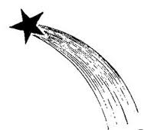

I hope that you will realize, (25)
life isn't always on your side.
I hope you know when hope is lost,
in me you can confide.

I hope that your glowing smile,
brings someone out of gloom. (30)
I hope you taste your life,
with more than just one spoon.

I hope that when you're lost,
you are also one to find.
And I hope that your hand, (35)
never grows too big for mine.

I hope you watch the stars shoot by,
upon a grassy hill.
I hope you know I love you,
always have and always will. (40)

Selected Response Questions

- Identify the rhyme scheme of the poem.
  - abba
  - abca
  - abca
  - abcb

- The poet’s use of the words “I hope”, throughout this poem is an example of what?
  - Metaphor
  - Onomatopoeia
  - Personification
  - Repetition

- “I hope that you understand that true love waits for you.” (line 13) is an example of which literary device?
  - Alliteration
  - Imagery
  - Personification
  - Simile

- That you may have to wait awhile, but when it comes it will be true. What part of speech is awhile?
  - Adjective
  - Adverb
  - Noun
  - Verb

- “I hope you feel the sand, hot on your toes on summer's day.” (line 17) is an example of which kind of imagery?
  - Auditory
  - Taste
  - Touch
  - Visual

- In line 27 the poet writes, “I hope you know when hope is lost, in me you can confide.” What part of speech is confide?
  - Adjective
  - Adverb
  - Noun
  - Verb

- Who is the intended audience of the poem?
  - Child
  - Friend
  - Parent
  - Student

- What is the tone of the poem?
  - Angry and jealous
  - Joyful and exciting
  - Morbid and dark
  - Positive and hopeful

Constructed Response Questions:

- In a well-developed paragraph state a theme or message for this poem. Support your response with two specific references from the poem.

Prepare an outline for your paragraph here.

__________________________________________________________________________________________________________________________________________________________________________________________________________________________________________________________________________________________________________________________________________________________________________________________________________________________________________________________________________________________________________________________________________________________________________________________________________________________________________________________________________

- In a well-developed paragraph (at least 6-8 sentences), explain how the following stanza relates to a relationship you have studied in a text this year.

“I hope you find a rainbow,
and realize it was worth the rain.
I hope that through your journey,
you’ll learn to balance smiles with pain.”

Prepare an outline for your paragraph here.

__________________________________________________________________________________________________________________________________________________________________________________________________________________________________________________________________________________________________________________________________________________________________________________________________________________
___________________________________________________________________________________________________________________________________________________________________________________________________________________________________________________________________________

A Friend I Can Count On
By Joanna Fuchs

When troubles come a callin’
As those gremlins often do,
And my spirit keeps on fallin’
Till I feel low down and blue…

When I look around for comfort, 5
Someone quickly jumps to mind,
One who always shows support,
And whose words are always kind.

Who will make my mood feel lighter,
Who’ll help beat my troubles back, 10
He/She makes the sun shine brighter
And gets my spirit back on track.

Who helps the road seem straighter,
And helps me get around each bend,
Who makes each day seem greater, 15
And that someone is you, my friend.

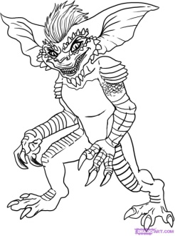

Selected Response Questions

- The poet’s use of the word “Who” in the last two verses is an example of what?
  - Metaphor
  - Onomatopoeia
  - Personification
  - Repetition

- Identify the rhyme scheme of the poem.
  - abab
  - abba
  - abca
  - abcb

- "When troubles come a callin'," is an example of which literary device?
  - Alliteration
  - Onomatopoeia
  - Personification
  - Simile

- Which literary device is the poet using when she writes, "As those gremlins often do"?
  - Alliteration
  - Metaphor
  - Onomatopoeia
  - Repetition

- In line 6 the poet writes, “Someone quickly jumps to mind.” What part of speech is quickly?
  - Adjective
  - Adverb
  - Noun
  - Verb

- “He/She makes the sun shine brighter and gets my spirit back on track.” is an example of which literary device?
  - Alliteration
  - Personification
  - Repetition
  - Simile

- Who is the intended audience of the poem?
  - A parent
  - A friend
  - A student
  - A teacher

- Which word best describes the mood (overall feeling) of this poem?
  - Angry and jealous
  - Anxious and hopeful
  - Morbid and dark
  - Proud and thankful

- In the context of the poem, what is the meaning of the word “beat” ( line 10)?
  - Rhythm
  - Stir
  - Strike repeatedly
  - Win

Constructed Response Questions:
- In a well developed paragraph, discuss two character traits the poet attributes to her good friend. Be sure to give examples from the poem.

Prepare an outline for your paragraph here.

_____________________________________________________________________________________________________________________________________________________________________________________________________________________________________________________________________________________________________________________________________________________________________________________________________________________________________________________________________________________
______________________________________________________________________________________________________________________________________

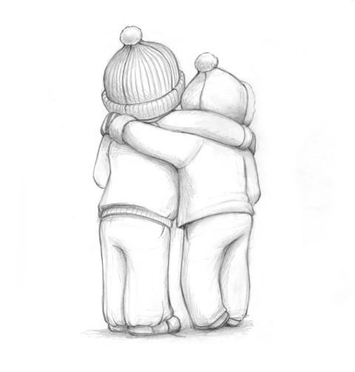
- In a well-developed paragraph, explain how the following stanza relates to either
A personal relationship you have
OR
A relationship you have studied in a novel this year.
When I look around for comfort,
Someone quickly jumps to mind,
One who always shows support,
And whose words are always kind.

Prepare an outline for your paragraph here.

__________________________________________________________________________________________________________________________________________________________________________________________________________________________________________________________________________________________________________________________________________________________________________________________________________________
___________________________________________________________________

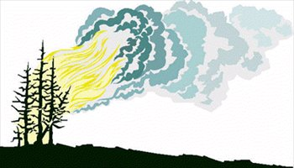
Forest Fire
by Elizabeth Coatsworth

The leaves were yellow, the leaves were red, 1
and bright and dry as the sun overhead,
the springs of the earth grew faint and slow,
and buckets came empty from wells below,
the wind went prying, now here, now there, 5
it tossed the dust and the leaves in the air,
it dried up the dew, the mists were driven
far away, and the clouds were riven
and scattered afar, the wind went whining,
it cleared the sky where the sun was shining. 10

Then the fire rose like an asp from the dust
and the colored leaves, and it ran like rust
along the ground ‘til it took on power
and it rose in the trees in tendril and flower,
and the wind gave a yell and the fire ran 15
with the wind behind it, and ruin began,
and the fire roared and fire hissed,
and smoke whirled up instead of the mist,
and the sun went down and the moon arose
with its light as chill and pale as the snows, 20
and the fire glowed against that light,
a moving red against tranquil white,
and the wind went on and the fire strengthened,
and the stain of its blackened shadow lengthened,
and very low and weak and small 25
the farm crouched there in the path of it all.

_________________________________________________________
riven: split in half tendril : a long stem, part of a plant
asp: snake tranquil: quiet and peaceful

Selected Response Questions:
- In which season is the poem set?
  - fall
  - spring
  - summer
  - winter

- What kind of day is it in the poem?
  - cool and foggy
  - dry and windy
  - humid and calm
  - rainy and hot

- What is the poet referring to in line 3 when she writes, “…springs of the earth grew faint and slow”
  - flowers blooming
  - tree roots showing
  - water drying up
  - birds chirping softly
- In line 4 the poet writes, “and buckets came empty from wells below.” What part of speech is buckets?
  - Adjective
  - Adverb
  - Noun
  - Verb

- What drove the mists away?
  - moon
  - rain
  - sun
  - wind

- In line 10, the phrase,”…the sky where the sun went shining.” illustrates which of the following?
  - alliteration
  - metaphor
  - personification
  - simile

- What literary device is shown in line 15 “the wind gave a yell…”?
  - alliteration
  - metaphor
  - personification
  - simile

- In line 17, the poet writes,” The fire roared and the fire hissed.” The word hissed is an example of what?
  - alliteration
  - metaphor
  - onomatopoeia
  - simile

- In line 19 the poet writes, “and smoke whirled up instead of the mist.” What part of speech is whirled?
  - Adjective
  - Adverb
  - Noun
  - Verb

- In line 20, “its” refers to which of the following?
  - the moon
  - the snow
  - the sun
  - the wind

- In line 22 “a moving red against tranquil white” illustrates what type of imagery?
  - sight
  - smell
  - sound
  - taste

- What literary device is the poet using when she writes,” …the stain of its blackened shadow ....”?
  - metaphor
  - onomatopoeia
  - personification
  - simile

- What is the rhyme scheme of the first four lines of this poem?
  - aabb
  - abab
  - abac
  - abba

- Which of the following is a possible theme for this poem?
  - be prepared
  - fire does not discriminate
  - good versus evil
  - work hard

Constructed Response Question
- Reread the last two lines of the poem and answer the question that follows.
“ And very low and weak and small
The farm crouched there in the path of it all.”
In a well developed paragraph describe what you think happened next.

Prepare an outline for your paragraph here.

____________________________________________________________________________________________________________________________________________________________________________________________________________________________________________________________________________________________________________________________________________________________________________________________________________
__________________________________________________________________

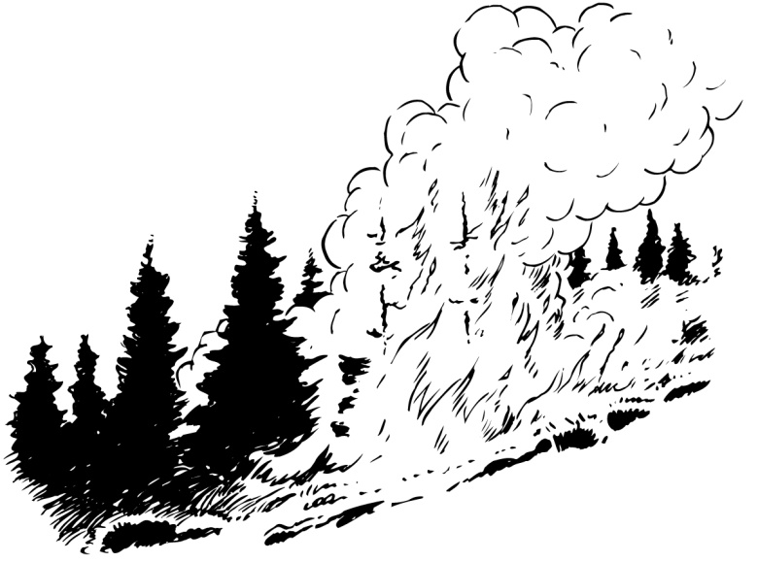

The Wind by R.L. Stevenson

I saw you toss the kites on high
And blow the birds about the sky;
And all around I heard you pass,
Like ladies’ skirts across the grass-
O wind, a-blowing all day long,
O wind, that sings so loud a song!

I saw the different things you did,
But always you yourself you hid.
I felt you push, I heard you call,
I could not see yourself at all-
O wind, a-blowing all day long,
O wind, that sings so loud a song!
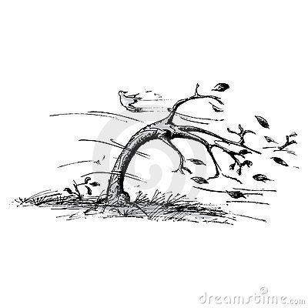
O you that are so strong and cold,
O blower, are you young or old?
Are you a beast of field and tree,
Or just a stronger child than me?
O wind, a-blowing all day long,
O wind, that sings so loud a song!

__________________________________________
Selected Response Questions
- What poetic device is shown in the line: “Like ladies skirts across the grass”?
  - Alliteration
  - Metaphor
  - Personification
  - Simile

- What poetic device is used in the line: “O wind, that sings so loud a song”?
  - Alliteration
  - Metaphor
  - Rhyme
  - Simile

- In the line, “Oh you that are so strong and cold”, what part of speech are the words strong and cold?
  - Adjectives
  - Adverbs
  - Nouns
  - Verbs

- What is meant by the line, “I could not see yourself at all”?
  - The narrator could not see herself.
  - The narrator could not see the wind.
  - The narrator had gone blind with the wind storm.
  - The narrator had lost her friend in the wind.

- Which word best describes the tone of the poem?
  - Angry
  - Curious
  - Sad
  - Scared
Constructed Response Questions
- Imagery appeals to your five senses and is used vividly by Stevenson in the poem, “The Wind”.
In a well-developed paragraph identify two different types of imagery used and give an example of each.
Prepare an outline for your paragraph here.

_______________________________________________________________________________________________________________________________________________________________________________________________________________________________________________________________________________________________________________________________________________

The Teacher

There she was
the monster of his deepest
nightmare
walking to his desk with a frightening pace
Brimming with authority.

Suddenly, she stopped
with the ultimate weapon
in her hand
The “test paper”.

Then the sheet dropped
to his desk like the fall
of a feather
But to him it was like the descent
of a thousand bricks.

He looked up with sickened
eyes
At the evil face that
ravages his mind.

It then spoke and said
with an old frail voice
“You got 100. Congratulations”.

Then the monster transformed
into a young and beautiful
princess
And walked away.

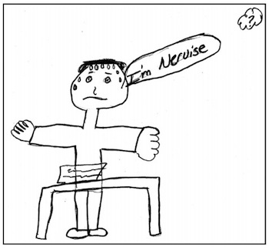

___________________________________________________

Brimming = filled to the top, overflowing
Authority = power.
Ravages = damages, destroys

Selected Response Questions

- ‘Suddenly she stopped’ is an example of:
  - Alliteration
  - Onomatopoeia
  - Personification
  - Rhyme

- Calling the “test paper” an ’ultimate weapon’, is an example of:
  - Hyperbole
  - Imagery
  - Repetition
  - Simile

- ‘Then the sheet dropped to his desk like the fall of a feather’ is an example of:
  - Metaphor
  - Personification
  - Rhyme scheme
  - Simile

- In the line ‘at that evil face’, the word ‘evil’ is used as a (or an):
  - Adjective
  - Adverb
  - Noun
  - Verb

- Which of the following best describes how the ‘monster’ approached the student in the first part of the poem?
  - Boldly, like a bull.
  - Excitedly, like a puppy.
  - Nervously, like a cat.
  - Sly, like a snake.

- In the poem, the teacher is first called a ‘monster’ and later is called a ‘princess’. Which of the following statements best explains the reason for this?
  - The teacher changes her appearance after the students tease her.
  - The teacher does not change, but is replaced by a prettier teacher halfway through the poem.
  - The teacher does not change, but the student sees her differently after a graded test is passed back.
  - The teacher is very angry, but becomes calm when a student smiles at her.

Bullying Takes New Form

By: TheLookingGlass

Fingers crawl along the keyboard like spiders in the dark.
A face, shrouded by nightfall, is lit only by the glare of a screen-
anonymity twists each beyond their waking selves.
Masks of text and font allow the sicker side to play.
On the playing field of the new age-
predators may slip into prey.
Tongues lash out through fingertips as
anger spills from one onto the other-
violence dominoes as the bullied plays the bully.
Peers hang each other with insults born in 12-point font,
times new roman becomes the weapon of choice,
war is waged not in the school yard or the locker room,
but is stored until the sun sets and all eyes turn to the internet.
Punches aren't thrown in crowded hallways,
bruises aren't blooming where anyone can see,
snickers aren't confined to the cafeteria,
and humiliation more than follows you home.
Times have changed and the pain is ever-present.
There is no safety for the battlefield is always there-
just beyond your finger tips.

Vocabulary:
Shrouded: concealed by
Anonymity: the state of being unknown

Selected Response Questions:

- Which literary device is used in line 1, “Fingers crawl along the keyboard like spiders in the dark”?
  - Alliteration
  - Metaphor
  - Personification
  - Simile

- “A face, shrouded by nightfall, is lit only by the glare of a screen-“. To which sense does this image appeal?
  - Sight
  - Smell
  - Taste
  - Touch

- What part of speech is the underlined word in line 4, “Masks of text and font allow the sicker side to play”?
  - Adjective
  - Adverb
  - Noun
  - Verb

- What does the underlined metaphor in line 5 represent? “On the playing field of the new age predators may slip into prey.”
  - the internet
  - the locker room
  - the school cafeteria
  - the school yard

- Which literary device is used in line 10, “Peers hang each other with insults”?
  - Alliteration
  - Hyperbole
  - Onomatopoeia
  - Simile

- “…times new roman becomes the weapon of choice” (line 11) is an example of which literary device?
  - Alliteration
  - Hyperbole
  - Metaphor
  - Simile

- Which literary device is used in line 16, “…humiliation more than follows you home”?
  - Alliteration
  - Hyperbole
  - Personification
  - Simile

- Which best expresses the theme (main idea) of this article?
  - Bullying only happens over the internet.
  - Cyber-bullies always reveal their true identity.
  - Cyber-bullying hurts less than physical bullying.
  - No one is safe from cyber-bullying at any time.

Constructed Response Questions

- The mood of a text is the overall feeling created by an author’s choice of words. It can be described by words such as light, happy, sad, dark, etc.
In a well-developed paragraph (6 to 8 sentences) discuss how the author of the poem and the online article were able to create different moods because of the words they chose. Give examples of two words or phrases which helped create the mood of each text.

Prepare an outline for your paragraph here.

________________________________________________________________________________________________________________________________________________________________________________________________________________________________________________________________________________________________________________________________________________________________________________________________________________________________________________________________________________________________________________________________________________________

“The Quarrel”
Eleanor Farjeon

I quarreled with my brother,
I don’t know what about,
One thing led to another
And somehow we fell out.
The start of it was slight,
The end of it was strong,
He said he was right,
I knew he was wrong!

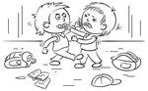
We hated one another.
The afternoon turned black.
Then suddenly my brother
Thumped me on the back
And said, “Oh, come along!
We can’t go on all night -
I was in the wrong.”
So he was in the right.

Constructed Response Questions

- “The Quarrel” by Eleanor Farjeon describes a conflict. In a well developed paragraph discuss the central conflict in this poem.

Prepare an outline for your paragraph here.

______________________________________________________________________________________________________________________________________________________________________________________________________________________________________________________________________________________________________________________________________________________________________________________________________________________________________________________________________________________________________________________________________________________________________________________________________________________________________________________

Glossary of Terms

Adjective: a word that describe nouns or pronouns.

Adverb: a word that help add meaning to or modifies a verb.
Alliteration: the repetition of the beginning sounds in groups of words, usually at the beginning of a word or stressed syllable; e.g., descending dew drops; luscious lemons
Audience: the people for whom a piece of literature is written

Character: is a person presented in a dramatic or narrative work; characters may be classified as:
Static – characters who do not change throughout the work, and the reader’s knowledge of the character does not grow;
Dynamic – characters who undergo some kind of change because of the action in the plot;
Flat – characters who embody one or two qualities, ideas, or traits that can be easily described in a brief summary;
Round – more complex characters who often display the inconsistencies and internal conflicts found in real people

Conflict: a struggle between opposing forces; conflict may be described as:
internal – an emotional struggle inside a person;
external – a struggle against the environment/nature or society;
interpersonal – a struggle with another person;
main – the central conflict that moves the plot forward;
minor – secondary conflict that does not influence the plot a great deal
Connection: a link that a reader can make between what they are reading and things they already know about.
Text-to-Self: When you make a personal connection to a text, you are making a text-to-self connection.
Text –to –Text: These are connections that readers make between the text they are reading and other texts the reader has read before.
Text–to –World: These are connections that readers make between the text and the bigger issues, events, or concerns of society.

Hyperbole: an exaggerated statement used not to deceive, but for humorous or dramatic effect; e.g., “It rained cats and dogs.”
Imagery: language that creates pictures in a reader’s mind to bring life to the experiences and feelings described in a poem; words that appeal to the reader’s senses and enables us to see (visual), hear (auditory), smell (olfactory), taste (gustatory), and touch (tactile) what the writer is describing

Inference combining clues in the text with prior knowledge to draw conclusions about objects, actions, locations, time, cause or effects, feelings, pastimes or occupations

Metaphor: a figure of speech that makes a comparison between two unlike things, without using the words like or as; e.g., “You are a dog.”
Mood: the overall feeling (e.g., light and happy or dark and brooding) created by an author’s choice of words

Noun: a naming word for a persen, animal, place, thing, and quality. In fact, it names everything around us including things that are invisible (wind, gas).

Onomatopoeia: the sound of a word resemble its meaning, e.g., buzz, hiss, etc.

Personification: a literary device in which human qualities or actions are attributed to non-human beings or objects

Point of view: the perspective the author establishes to tell the story; includes:
First person: (I) the narrator participates in the action of the story;
Third person: (he, she, Mary, Mr. Tucker, etc.) – the narrator does not participate in the action of the story; may be classified as:
Omniscient : the narrator presents the thoughts of more than one of the characters;
Limited : the narrator presents only his or her own thoughts which is only one side of the story

Repetition: the deliberate use of the same word, words, or events to create an effect

Rhyme: the same sound occurring in different words

Setting: the environment or surroundings in which a story takes place; includes time, place, and situation in which the characters are placed

Simile: a comparison between two unlike things using like or as; e.g., “My love is like a red, red rose.”

Stanza: a stanza in a poem is what a paragraph is to a piece of prose – stanzas are separated from one another by the use of spaces within a poem

Summary: a shorter, more concise form

Theme: the story’s main idea or message that the author intends to communicate by telling the story; often universal truths that are suggested by the specifics of the story

Verb: a verb is usually the action word. It describes what noun is doing.
Examples: run, broke, jumping, look, sailed.
Helping Verb: Sometimes verbs are made up of more than one word. The verb part that comes before the main verb is called a helping verb
Some examples are: am, was, be, has, do, must, can, will, shall

