**English 1201: Media Analysis**

**Name:**

Part of being media literate involves being able to **deconstruct media text**. When you deconstruct a text, you break it down into its components to see what messages and assumptions it carries. This is the careful and close analysis of a piece of media, looking beneath the surface – the characters, plot, language, etc. – to understand its deeper meanings. Any piece of media – a magazine ad, a sitcom, a conversation, a feature film, a TV commercial, or whatever – can be analyzed in this way.

You can use the following questions to quickly deconstruct a media example:

* Who paid for the media? Why?
* Who is being targeted?
* What text, images or sounds lead you to this conclusion?
* What is the text (literal meaning) of the message?
* What is the subtext (unstated or underlying message)?
* What kind of lifestyle is presented? Is it glamorized? How?
* What values are expressed?
* What tools or techniques of persuasion are used?
* What story is not being told?
* In what ways is this a healthy and/or unhealthy media message?
* What media strategies are used and how are they effective in achieving a purpose?

**Media Deconstruction Terms**

**Advertisement:** A communication form that employs sophisticated, often subtle methods of persuasion to not only get you to part with your money or win your support, but to play on your desires, emotions, and biases to change the way you think. Propaganda is a part of this. Not all forms of advertising are bad

**Audience**: whom is the artist aiming the message at?

**Agenda:** plan, goals to be achieved through advertising

**Bias:** is a mental leaning or inclination; partiality; prejudice; bent

**Commercial:** type of advertisement

**Context**: the situation in which an image appears. This situation can affect its meaning. A McDonald’s logo conveys a different message when viewed on a food wrapper (advertising) than when it is viewed in a CBC documentary (criticism).

**Icon:** A person or thing regarded as a representative symbol of something: "icon of manhood".

**Image:** A representation of the external form of a person or thing in sculpture, painting, etc.

**Intent:** purpose

**Juxtaposition:** the act or an instance of placing two or more things side by side.

**Logo:** an identifying symbol used to advertise and promote an organization, event, product or service. Usually, such symbols combine pictorial and textual elements in a distinctive manner. When consisting solely of stylized textual elements, such symbols are referred to as logotypes or wordmarks.

**Mass Media:** when media methods are used to communicate to thousands of people at the same time

**Media:** forms of public communication (such as newspaper, radio, television, information network, poster, or brochure) that are designed to reach large numbers of people.

**Medium:** singular of media

**Message:** any thought, idea, or information, whether expressed in plain or in secret language, prepared in a form suitable for transmission by any means of communication.

**Motive:** reason for doing something eg, make money, change opinion, etc…

**Poster:** form of communication that has varied purposes such as promoting events, presenting social commentary, persuading the viewer to purchase etc. The design of the poster must ensure that message is consistent with purpose.

**Product:** Item to be sold, serviced etc.

**Product Placement:** An advertising strategy in which commercial products or brands are placed within a play, film, broadcast program, video game or print medium for financial gain. **Example:** If Heinz Ketchup is being used by a character in a movie, it is most likely product placement.

**Purpose**: what message is the artist trying to get across?

**Sub-text:** hidden messages revealed through images, signs, symbols, text; works on the sub-conscience level

**Target Audience:** consumer group most likely to buy a specific product and identified by region, age, demographics, or economic status. Effective ads are created and placed in media with the target audience clearly in mind.

**Strategies in Advertising/Media**

1. **Bandwagon:** this technique appeals to your desire for conformity; if you don't buy the product, you are not up-to-date or part of the in crowd, so jump on the bandwagon.

Example: Every day, thousands are switching to Lay's Potato Chips.

1. **Cartoon/Cute Characters:** this technique relies on the entertainment value of the cute character to encourage us to purchase the product often creates sensitivity and emotional appeal.

Example: The Charmin bear uses toilet tissue.

1. **Celebrity Endorsement**: this technique involves a public figure speaking on behalf of a product; the plan is that your admiration for the singer or sports star will cause you to buy the product Example: Lady Gaga wears Red Door perfume, and so should you.
2. **Emotional Appeal**: this technique appeals to one of our emotional needs

Example: Buy Nutella and you will be a great parent, providing your child with good nutrition.

1. **Facts and Figures:** this technique tells the consumer that this product has been proven to be the best buy or the most effective or whatever; the implication is that figures and statistics prove a point beyond dispute. Often "tests" have been conducted to prove this

Example: In clinical studies, Crest has been clinically proven to whiten teeth.

1. **Gender/Sex Appeal**: this technique uses sex or gender connection to sell a product

Example: Buy Axe and all the women will want you.

1. **Name Calling** - this technique uses slander of the opponent to win support

Example: The current government has not managed your tax dollars well. They have been wasteful.

1. **Plain Folks**: this technique appeals to people who feel that they want products for ordinary folks; often these people are family oriented, and certainly those who feel that they are down-to-earth, part of average society. Talking down to the viewers in order to appear just like them: “Use Tide. It makes your clothes as white as Mom used to wash them” The plain folk’s device is an attempt by the propagandist to convince the public that his views reflect those of the common person and that they are also working for the benefit of the common person.

Example: Shop at Walmart; we make family budgets go further.

1. **Shock Appeal:** this technique involves shocking you into believing that you should buy or do something. Shock advertising is a method of advertising that purposely offends and startles its viewers in an attempt to “gain attention. Containing disgusting images, sexual references, profanity and obscenity, religious taboos, vulgarity, impropriety (violations of societal “norms”), or moral offensiveness are considered to be “shocking”

Example: there is a very scary old ad for a cell phone that has a woman stranded on a deserted road with no phone and an unknown man in a pickup stopping to check on her

1. **Snob Appeal:** this technique involves convincing you that the product is for people who will have only the best; people who choose the product involved here are "in a league above the rest" The association of a product with a desirable lifestyle.

Example: Come dine at The Keg, where we cater to those who deserve the best.

1. **Testimonials:** This technique is opinion based and usually includes a person’s good luck story (I used Weight Watcher and lost 75 lbs). Often uses quotations or endorsements, in or out of context, which attempt to connect a famous or respectable person with a product or item. Testimonials are very closely connected to the transfer technique, in that an attempt is made to connect an agreeable person to another item.
2. **Humour:** The technique of attracting a viewer’s attention through the use of items that provide a light hearted view of a product but result in the viewer remembering what they have seen with little to no effort.

***Types of Questions you could be asked about advertisements:***

1. What is the purpose of the ad?
2. What message is being conveyed in the ad?
3. What social values are evident in the ad?
4. Who is the target audience?
5. Any stereotyping? Bias? …
6. What Strategies are being used in Advertising/Media and how are they effective.

**Media Strategies Practice**

|  |  |  |
| --- | --- | --- |
| **Identify the Media Strategy state why it is effective.** | | |
|  |  |  |
| bandwagon | cartoon or cute characters | snob appeal |
| celebrity endorsement or testimonial | emotional appeal | plain folks |
| facts and figures | gender/sex appeal | shock appeal |
| name calling |  |  |

|  |  |
| --- | --- |
| https://amarillotxcoc.wliinc1.com/External/WCPages/WCWebContent/WebContentPage.aspx?ContentID=1831 | http://dominicl.weebly.com/uploads/2/2/9/5/22956172/582527889.jpg?510 |
| Strategy: ___________________________________  Effective: __________________________________  ___________________________________________  ___________________________________________  ___________________________________________ | Strategy: ___________________________________  Effective: __________________________________  ___________________________________________  ___________________________________________  ___________________________________________ |
| http://anextweb.com/wp-content/uploads/2015/08/article-0-13201269000005DC-307_1024x615_large.jpg | https://s-media-cache-ak0.pinimg.com/236x/63/97/f3/6397f39bece74a42f234e0db9f9aedff.jpg |
| Strategy: ___________________________________  Effective: __________________________________  ___________________________________________  ___________________________________________  ___________________________________________ | Strategy: ___________________________________  Effective: __________________________________  ___________________________________________  ___________________________________________  ___________________________________________ |

**Media Strategies #1**



1. What is the form of this visual?
   1. Advertisement
   2. Cartoon
   3. Poster
   4. Web page
2. What best describes the purpose of the visual?
   1. to advertise
   2. to entertain
   3. to inform
   4. to inspire
3. Who is the target audience for this visual?
   1. Advertisers
   2. Children
   3. Parents
   4. Teenagers
4. What is the dominant element used to support the message?
   1. Balance
   2. Focal Point
   3. Juxtaposition
   4. Line
5. What is implied by the logo on the bottom right of the visual?
   1. That looking at the internet can cause eye problems.
   2. That television is in the eye of the beholder.
   3. That there are organizations that are concerned for children’s exposure to television.
   4. That you should not believe everything you see on the television.
6. What dominant media strategy is used in the visual?
   1. Cartoon characters
   2. Celebrity endorsement
   3. Emotional appeal
   4. Plain folks
7. State a **message** for this visual and support your answer with reference to two (2) specific examples from the text.

__________________________________________________________________________________________________________________________________________________________________________________________________________________________________________________________________________________________________________________________________________________________________________________________________________________________________________________________________________________________________________________________________________________________________________________________________________________________________________________________________________________________________________________________________________________________________________________________________________________________________________________________________________________________

**Media Strategy #2**

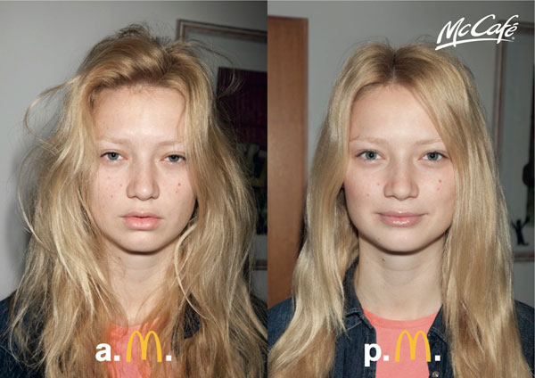

1. What is the form of this visual?
   1. Advertisement
   2. Cartoon
   3. Poster
   4. Web page
2. What is the iconic logo in this visual?
   1. Fast food
   2. McCafe
   3. M
   4. The female image
3. What is the target audience for this visual?
   1. Children
   2. Elderly
   3. Parents
   4. Teenagers
4. What is the dominant element used to support the message?
   1. Focal Point
   2. Juxtaposition
   3. Proportion
   4. Scale
5. What dominant media strategy is used in the visual?
   1. Cartoon characters
   2. Celebrity endorsement
   3. Plain folks
   4. Shock appeal
6. State the purpose of the visual. Explain how two (2) different media strategies are used effectively to convey the purpose of the visual.

______________________________________________________________________________________________________________________________________________________________________________________________________________________________________________________________________________________________________________________________________________________________________________________________________________________________________________________________________________________________________________________________________________________________________________________________________________________________________________________________________________________________________________________________

__________________________________________________________________________________________________________________________________________________________________________________________________________________________________________

__________________________________________________________________________________________________________________________________________________________________________________________________________________________________________

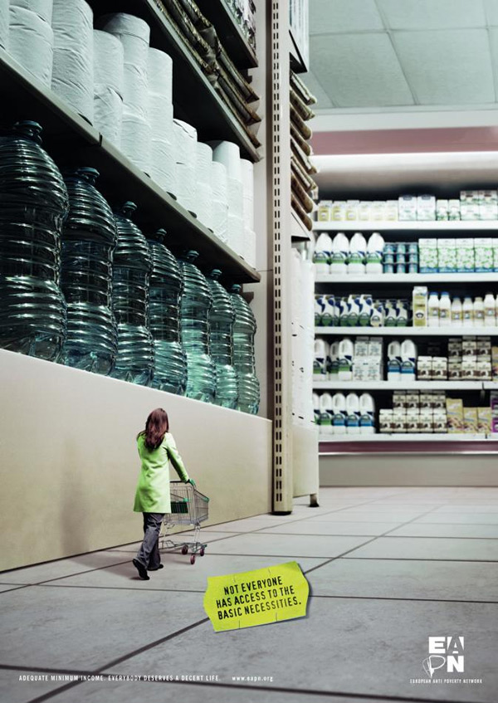**Media Strategy #3**

1. What is the form of this visual?
   1. painting
   2. poster
   3. public service announcement
   4. web page
2. What best describes the purpose of the visual?
   1. to advertise
   2. to educate
   3. to entertain
   4. to inspire
3. What is the target audience for this visual?
   1. adults
   2. children
   3. homeless
   4. teenagers
4. What best describes the mood of the visual?
   1. concerned
   2. determined
   3. suspenseful
   4. threatening
5. Identify **two** (2) different **media strategies** used in this advertisement and explain how each are used **effectively** in conveying the **message**.

________________________________________________________________________________________________________________________________________________________________________________________________________________________________________________________________________________________________________________________________________________________________________________________________________________________________________________________________________________________________________________________________________________________________________________________________________________________________________________________________________________________________________________________________________________________________________________________________________________________________________________________________________________________________________________________________________________________________________________________________________________________________________________________________________________________________________________________________________________________________________________________________________________________________________________________________________________________________

**Media Strategies #4**

Identify **one** **media strategy** used in this advertisement and explain how it is used **effectively** in conveying the **message**.

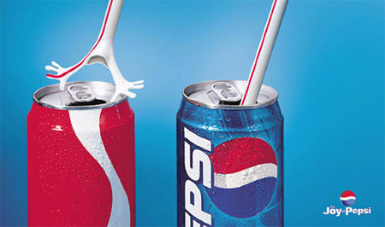

__________________________________________________________________________________________________________________________________________________________________________________________________________________________________________________________________________________________________________________________________________________________________________________________________________________________________________________________________________________________________________________________________________________________________________________________________________________________________________________________________________________________________________________________________________________________________________________________________________________________________________________________________________________________________________________________________________________________________________________________________________________________________________________________________________________________________________________________________________________________________________________________________________________________________________________________________________________________________________________________________________________________________________________________________________________________________________________________________________________________________________________________________________________________________________________________________________________________________________________________________________________________________________________________________________________________________________________________________________________________________________________________________________________________________________________________________________________________________________________________________________________________________________________________________________________________________________________________________________________________________________________________

**Media Strategies #5**

Identify **two** (2) different **media strategies** used in this advertisement and explain how each are used **effectively** in conveying the **message**.



