Name: __________________________________ Class: 2201 –

Short Story Unit
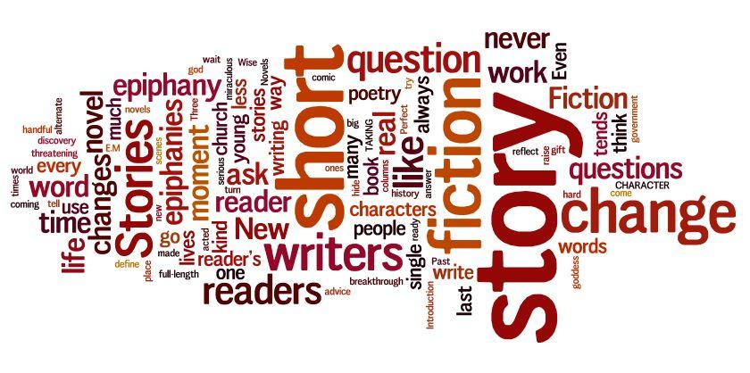
“The Necklace” by Guy de Maupassant (Views and Viewpoints P. 322)

- State a theme for the short story “The Necklace” using two direct references for support.

- Using two references for support, identify and explain the irony in the story.

- Identify and explain three methods used to reveal character. Use two direct references for support.

Personal Symbol Response: Write about an object that has special symbolic meaning for you. It might be a gift from someone you love, an award of which you are proud, a souvenir from a place you miss, a childhood toy you still treasure, a family photograph, whatever. Describe the object, appealing to the senses as appropriate and giving specific details. Also explain what it symbolizes for you.

“The Leap” by Louis Erdrich Echoes p. 190

- Explain the effectiveness of the point of view used in “The Leap” Use two specific references for support.

- Using two examples, explain how suspense is developed. (Consider: sentence types, diction, foreshadowing…)

- Explain the significance of the title of a story. Use two references for support.

- Look Who I Look Up To: Think of two people of established reputation whom you admire. You may need to do some formal research on these people, so don't choose your Aunt Helen unless she's in the encyclopedia. You must be specific. If you admire Martin Luther King, Jr., saying he fought for civil rights isn't enough. Exactly what did he do? Devote one solid paragraph to each person, telling what each person has done to deserve your admiration.

“The Lottery Ticket” by Anton Chekov Echoes p. 198

- Explain how the mood of the story changes from the beginning to the end. Use two references for support.

- Using two references for support, identify and explain the irony in the story.

- The story is told from a “third-person omniscient” point of view (in which the narrator knows the thoughts of all characters.) Why is this an effective way to tell this story?

- The story is a satire (a form of writing in which the author criticizes people and/or society). What point about human nature do you think the author is making?

“The Money Crowd” Land Sea & Time by Joanne Soper-Cook

- The line “The money crowd”. (p. 126) is used

  - to create transition
  - to provide a summary of ideas
  - to emphasize an idea
  - to create interest

- The line “…money draped across pale shoulders, money glimmering on slender fingers, money glistening in great chunks…” (p. 126) is an example of:

A.) paradox and parallelism
B.) metaphor and repetition
C.) personification and parallelism
D.) imagery and parallelism

- Read the following sentence and define the words in bold, and in your own words explain what you learn (from this sentence) about the narrator.

“I reasoned that my mother only dressed me the way she did so that I might better experience the local colour, and achieve that patina of elegance that derives its existence from an intuited superiority.”

Patina:

Derives:

Intuited:

What Did You Learn?

Unity: refers to ONENESS in writing. Overall this means oneness of a topic.

How Unity is achieved in essay writing:
- By using a strong and clear thesis statement in the Introduction
- Possible developmental ideas are presented in the Introduction
- Strong topic sentences are used in each body paragraph
- Using repetition of the thesis statement in the conclusion
- Closing by return

Unity should create or develop the following:
- a single focus - expository essays; a dominant impression - descriptive essays; concentrate on one single story - narrative essays

- How does the author create unity at the end of the story?

- Diction refers to the language of a piece of writing, and how each word is chosen to convey a precise meaning. Writers deliberately choose words for its particular effect, so it's important to know the origins and connotations (implied meaning) of the words in addition to their literal meaning.

Explain how the author’s use of diction is effective in the line “I’d begun upon which was pinned the winding trail of paper carnage.” (p. 126)

“Middle Son” Land Sea & Time by Patrick O’Flaherty

- Setting (time, place, and circumstance) is a significant part of short stories. Choose evidence from the opening paragraph to show that this story is set many years ago in rural Newfoundland.

2. The phrase “slow to middling” (p. 187) is an example of a
A.) allegory
B.) blank verse
C.) colloquialism
D.) simile

- Suspense is used to keep the reader interested. How does O’Flaherty create suspense through the character of Colin?

- Describe the relationship between Jimmy and Colin. How do you explain the violent confrontation at the end of the story?

- Conflict is a major element in literature. There are several types of conflict:
- internal - a struggle that takes place in a character’s mind
- man against himself
- interpersonal - a struggle between specific characters
- external – a struggle between opposing forces
- man against society
- man against nature

Complete the chart to identify the types of conflict in “Middle Son”
Identify the characters and choose the conflict(s) they experience. | Write a brief explanation of the conflict.
Character(s) | External | Interpersonal | Internal

